User Guide for the
The Low-income Public Purpose Test
(LIPPT)

Updated for Version 2.0

May 25, 2001

Prepared for

RRM Working Group
Cost Effectiveness Committee

Prepared by
TecMarket Works
165 West Netherwood Road, Suite A, 2nd Floor
Oregon, WI 53575
Voice: (608) 835-8855
Fax: (608) 835-9490
Mail@TecMarket.net

Skumatz Economic Research, Inc.
and
Megdal and Associates



Table of Contents

Introduction 1
Using the Calculating Model 3
Worksheet Cover 3
Worksheet 1 Overall Summary 4
Worksheet 2 Energy Rates 8
Worksheet 3 Measure Cost & Summary 10
Worksheet 4 Cost Summary 13
Structure of the NEB Worksheets of the Model 18
Worksheet 5A NEB Total 21
Worksheet 5B NEB Assumptions 22
Worksheet 6 NEB Results 25
Worksheets: 7A-7K, 8A-8D, and 9A-9K – Detailed NEB Computation Worksheets 29
Worksheets: 7A, 7B, 7C, 7D, 7E, 7F, 7G, 7H, 7I, 8C, 8D, 9A, 9E, 9H 31
Worksheets: 8A, 9B, 9D, 9F, 9G 32
Worksheets: 7J, 8C, 9G. 34
Worksheets: 7K, 8B, 9C, 9I, 9J 35
Worksheet 10 Measure Benefit Archives 36
Worksheets: 11A-11F 37
Worksheet 12 NEB & Measure Ratios 39
Worksheet CONFIDENTIALITY UtilNEBDataInputs 41
NEBs Appendix 42
Terms and Units: What is Being Computed 42
Time Horizons for the Benefits – Annualizing and NPV 42
More Information on Data Inputs 45
Description of Computation Method for NEBs 47

Introduction
This user’s guide presents the instructions for operating the California Low-Income Public Purpose Test (LIPPT), model, version 2.0. The LIPPT is developed for the Reporting Requirements Manual Subcommittee for use in reporting cost effectiveness for program year 2000 low-income programs. The LIPPT model was created by TecMarket Works and Skumatz Economic Research Associates (SERA Inc.), with support from Megdal and Associates. The model was developed in response to an RFP from the California Reporting Requirements Manual Working Group Subcommittee on Cost Effectiveness Testing. This model is built in Microsoft Excel. The four investor-owned utilities (IOUs) in California can use this model to quantify the cost effectiveness of low-income energy efficiency programs. These companies include Southern California Edison (SCE), Southern California Gas (SoCalGas), Pacific Gas and Electric (PG&E), and San Diego Gas and Electric (SDG&E).
This model includes calculations for estimating the energy benefits and costs of a Low Income Energy Efficiency (LIEE) program, as well as the benefits associated with a wide range of non-energy benefits (NEBs) that can be attributed to a LIEE program. The model allows users to enter program specific values for:
- Real discount, energy escalation and inflation rates,
- Per measure costs,
- Program-related non-measure cost elements,
- Expected Useful Life (EUL) of installed measures,
- Per measure energy savings, and
- Non-energy Benefits (NEBs)
The EUL of each measure and the most current energy savings values (provided by the four California utilities) are also stored in the model. The user can select the mix of measures, energy savings values, and non-energy benefit values from what is already provided in the model, or the user can revise the values in the model as needed. The model allows for the added flexibility of having any cost element “turned on” for inclusion in the cost benefit calculation or “turned off” for exclusion. This same flexibility is provided for each non-energy benefit and at the energy efficient measure level, allowing the user to “turn on or off” any specific measure to include it or exclude it from the cost effectiveness calculation. The ability to “turn on and off” different program costs, measure costs, energy savings, non-energy benefits allows the user to instantly view how modifications to the program can be expected to impact cost effectiveness.

The model is comprised of 42 worksheets interconnected through various calculated fields, objects, and switches. The 42 worksheets comprising this model (and described in detail in Chapter 2) are:
- 1 Overall Summary
- 2 Energy Rates
- 3 Measure Cost & Savings
- 4 Cost Summary
- 5A Total and 5B NEB Assumptions
- 6 NEB Results
- 7A-7K → Detailed worksheets on NEBs from program participant persective
- 8A-8D → Detailed worksheets on NEBs from society perspective
- 9A-9K →Detailed worksheets on NEBs from utility perspective
- 10 Measure Benefits Archives
- 11A-11F illustrate results of the test in the form of graphical outputs
- 12 NEB & Measure Ratios
- CONFIDENTIAL-UtilNEBDataInputs
The user can move between these worksheets by clicking on the worksheet identification tabs at the bottom of the screen. Each worksheet identification tab is numbered, with a label describing the contents of the sheet.
The non-energy benefits are supported by yellow tables located to the far right in each detailed NEB worksheet. Each yellow table displays a specific set of non-energy benefits, allowing the user to customize their cost effectiveness calculation. The user may also include or exclude each type of non-energy benefits included in the model through a set “on/off” switches located on the “6 NEB Results” worksheet.

Using the Calculating Model
For the purposes of clarity, the 42 worksheets of this model are referred to in ”Italics” and the variable names included are described within ‘single quotes.’
Throughout the model, user data entry can only occur in two ways:

White fields - are where the user can make direct entries.
Check boxes - are contained on cost, energy, and non-energy benefit worksheets to allow the user to select which benefits or costs to include or exclude from the program. Check boxes are also contained within yellow tables located off the right of the main table on most of the NEB worksheets. Here the check boxes are used to select which values from the literature will be applied to the test. Default values are already selected, so no changes are required in yellow tables found on the NEB detailed worksheet note that the “default” value checkboxes selected as defaults are background-shaded in blue.

No entries are made in blue fields (explanation, computations, etc), gray fields (calculated results or those transferred from other worksheets) or any other areas.
The following sections of this manual provide an overview of the LIPPT and describe how to use the model to calculate a program’s benefit cost ratio. Please note that, throughout this model, the gray or blue background shaded fields do not require data entry and are protected so that data cannot be inadvertently entered into the model in a way that will change the calculation methods. The user of this model should only insert data into fields with white backgrounds.

Worksheet Cover
This is simply the title page of the model and requires no data entry.

Worksheet 1 Overall Summary
illustrates the appearance of the 1 Overall Summary worksheet. The user is required to enter data in the following 5 fields:
- ‘Program Year’
- ‘Name of Program’
- ‘Utility’
- ‘Program Type’
- ‘Number of Participants’
These 5 fields are background shaded white, indicating that they require data entry. ‘Program Year’ and the Utility with which the program is associated are selected using the drag down lists. The other 3 fields ‘Name of Program,’ ‘Program Type,’ and ‘Number of Participants’ require manual entry. It is up to the user to enter a word or phrase for ‘Program Type,’ such as “Direct Install,” “Weatherization” or “General Residential.” The ‘Name of Program’ field does not drive any calculations in the model. However, the correct selection of the ‘Utility’ and ‘Number of Participants” are very important to the computations in this model.
The remaining blue and gray-shaded fields in 1 Overall Summary provide information about the program’s cost effectiveness, including the cost effectiveness ratio, costs associated with the program’s implementation, and a summary of program benefits, including the total value of the energy saved and the total value of the non-energy benefits. These fields are calculated fields that are based on information entered in other worksheets and should not be changed. These fields and their content are described below.
‘LIPPT Benefit-Cost Ratio’ is the overall program benefit-cost ratio, which is the NPV of ‘Total Life-Cycle Savings’ divided by ‘Total Program Costs.’ Since the benefit-cost ratio is the most important overall output from this model, it is repeated and displayed at the top of each worksheet in this model. This display allows the user to instantly see how changes they make within each of the worksheets impact the LIPPT cost-benefit ratio. This feature allows the user to try different program scenarios and assumptions to see how specific program changes impact the benefit-cost ratio of the program.
Just below the ‘Number of Participants’’ field, there is a row of 5 gray background shaded fields that display summary dollar values of the overall program costs and benefits for the following:
- ‘Total First Year Energy Savings,’
- ‘NPV of Total Life-Cycle Energy Savings,’
- ‘NPV of Total Life-Cycle Non-Energy Benefits,’
- ‘NPV of Total Savings (Energy + Non-Energy),’ and
- ‘Total Program Costs.’

These 5 fields are computed from the data entered on the other worksheets in this model. ‘Total First Year Energy Savings’ and the ‘NPV of Total Life-Cycle Energy Savings’ are based on data entered on 2 Energy Rates and 3 Measure Cost & Savings. The ‘NPV of Total Life-Cycle Non-Energy Benefits’ is based on 4 NEBs Summary. The ‘NPV of Total Savings’ is the sum of ‘NPV of Total Energy Savings’ and ‘NPV of Total Non-Energy Benefits.’
Below the dollar values there is another row of 5 gray background shaded fields that display overall program energy saving by fuel type. These fields include:
- ‘Total First Year kWh Savings,’
- ‘Total First Year Therms Savings,’
- ‘Total Electric Life-Cycle Savings in kWhs,
- ‘Total Gas Life-Cycle Savings in Therms,’ and
- ‘Total Life-Cycle Savings in Billions of BTUs (Gas & Electric).
These 5 outputs are based on data entered on 3 Measure Cost & Savings. The program’s total first year kWh and therm savings are calculated by multiplying the first year measure-specific savings (which are entered for each measure on 3 Measure Cost & Savings, by the number of measures installed, for all installed measures in the program. The program total life-cycle savings (in both kWhs and therms) are calculated by summing the multiplication of the first year energy savings for each measure, by the estimated useful life (EUL) for that measure. The ‘Total Life-Cycle Savings in Billions of BTUs (Electric and Gas)’ is the sum of the total gas and electric life-cycle savings combined and converted into British Thermal Units (BTUs).
At the very bottom of this worksheet, three columns of gray background shaded fields are displayed that summarize the program non-energy benefits to the utility, society and ratepayer. Non-energy benefits are broken out into 3 categories: utility, society, and participant. For each of these groups the non-energy benefits are expressed in 3 different ways:
- First year savings per participant
- First year savings for all participants
- Life-cycle savings for all participants

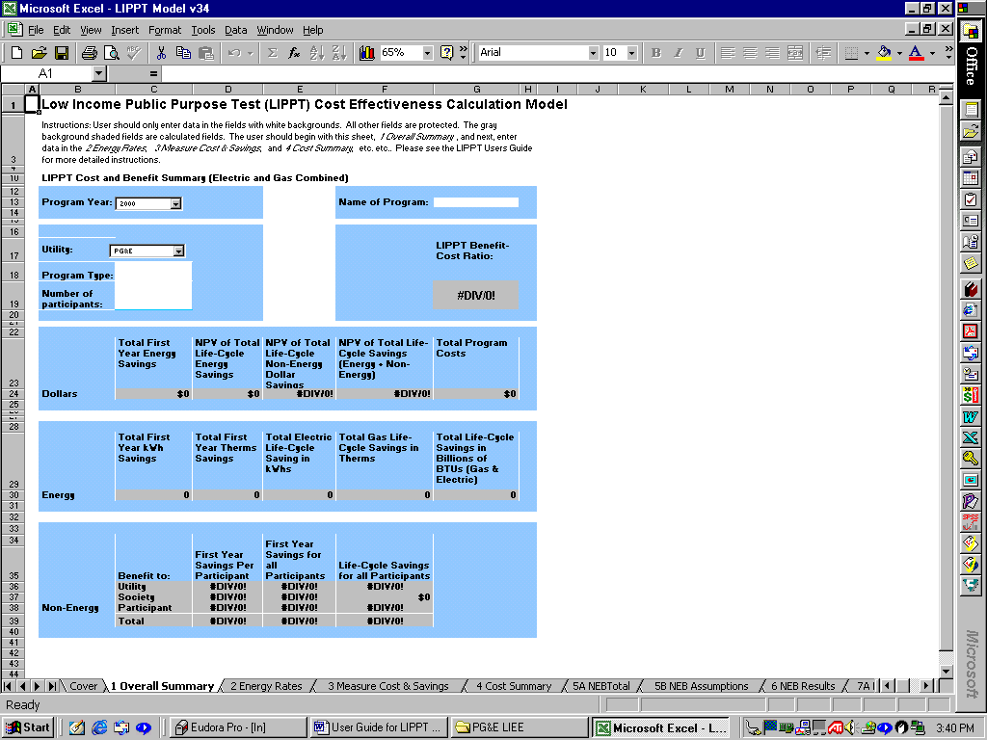

Figure 1 Worksheet 1 Overall Summary

Worksheet 2 Energy Rates
The next worksheet is 2 Energy Rates. This is the worksheet on which the user enters the following:
- ‘Real Discount Rate’
- ‘Inflation Rate’
- Natural Gas and Electric Energy Escalation Rate
- Utility avoided costs for natural gas and electricity

Utility avoided cost of electricity and natural gas are used in this model. Figure 2 below illustrates the fields on which the user can change the values for the ‘Real Discount Rate’ and the ‘Inflation Rate.’ These fields are located on the left side 2 Energy Rates worksheet. The ‘Inflation Rate’ is the rate of inflation for goods and services in the general California economy. The ‘Real Discount Rate’ is used to discount the future worth of energy savings to a present dollar value. In other literature, the ‘Real Discount Rate’ is occasionally referred to as the societal discount rate. Five-percent is the default value included in the model. This value was established by the RRM Cost Effectiveness Working Group, however, this value can be updated as needed by changing the value. The ‘Inflation Rate’ for electricity and natural gas is assigned a default value of 3%, and this also can be changed in the model. Both the ‘Real Discount Rate; and the ‘Inflation Rate’ discount the future worth of program related energy savings. In both cases, higher values decrease the NPV of energy savings, and lower values increase savings. The ‘Inflation Rate’ is incorporated with the ‘Real Discount Rate’ and are used together to compute the ‘Nominal Discount Rate.’
The user may also change the ‘Energy Escalator Rate’ (fuel inflation rate) for electricity and natural gas from the default value of 3%. The electric and gas ‘Energy Escalator Rate’ in included in the model because the inflation rate for energy is seldom identical to the inflation rate of the general economy. Changes to the ‘Energy Escalator Rate’ will change the projected energy rates for electricity and gas displayed on the right hand side of the worksheet. The projected energy rates are used to value future energy savings before they are adjusted to their NPV.
The user also needs to set the first year avoided utility cost for both electricity and natural gas. To accomplish this, the user may enter/change a value for the first year utility avoided cost of electricity in $/kWh and enter the same for the retail price of gas in $/Therms. The year (i.e. 2000) that is selected on the “1 Overall Summary” Worksheet is year number 1 on this worksheet. The default values chosen for year number 1 are $0.0451/kWh and $0.385/Therm, respectively. For the LIPPT model, the energy rates are based on the utility’s avoided cost, rather than the participant’s cost. However, the user may chose energy rates based on other costs and perspectives as appropriate. Rates for years 2 through year 30 are driven by the ‘Utility Avoided Electric Rate - $/kWh’ and ‘Utility Avoided Gas Rate - $/Therm’ from year 1, adjusted by the energy escalator rate.
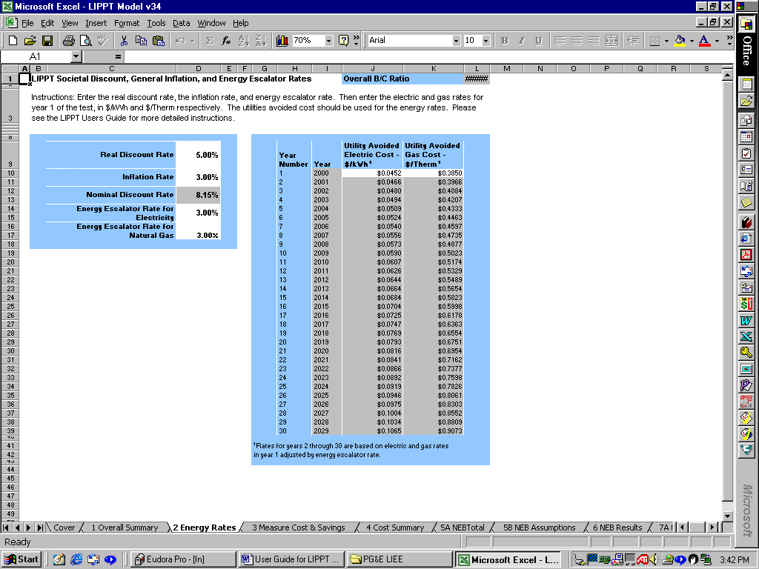

Figure 2 Worksheet 2 Energy Rates

Worksheet 3 Measure Cost & Summary
Figure 3 shows the 3 Measure Cost & Summary worksheet. This is the worksheet on which program-installed measure information is recorded. This worksheet displays the names of the kinds of energy efficient measures typically installed by California’s low-income energy programs. However, there is also room for adding measures to the test as new measures are added to California’s LIEE programs. Information to be recorded on this worksheet includes the number of measures installed, the energy savings from the measures and the cost of installing each measure. This is the data that is used to calculate both the program-wide benefit cost ratio and the per-measure ratios. Similar to the program cost worksheet, each measure can be turned “on” or “off” to include or exclude both the costs and the energy savings associated with a single type of measure. This added flexibility allows users to examine the changes in a program’s benefit cost ratio as measures are added or deleted from the analysis.
Column C of the Measure Cost & Summary worksheet is the measure-specific on/off switch. A check in the box (3) in column C indicates that the measure is turned on. By “clicking” away the check-mark in this field with the users left mouse button the measure is “turned off,” and is not used in the calculation. By clicking the box again, the measure is turned back on, and is used. The default setting is that the measure is turned on, and users must turn off the measures that they want excluded from the calculation. Another method of not including a measure in the calculation is to not place data into the data entry fields associated with a specific type of measure.
The next column (Column D) is the type of measure, as classified by current measure reporting requirements. The “Measure Classification” consists of three different types of measure classes. These are: electric measures (Elec), gas measures (gas) and weatherization measures (Weath). The user of the LIPPT records measure-specific data into the measure classifications appropriate for their program filings and impact reporting criteria. There are extra rows at the bottom of each measure class, where the measure name (Column F) is not filled in. This is the area left intentionally blank and can be used for adding additional measure (See Figure 3 below).
Column E displays the Effective Useful Life (EUL) of each measure. This is the average number of years that energy savings are expected to last for each type of measure installed. This number reflects how long that measure is expected to provide savings under the condition appropriate for each individual measure, as installed through the program being evaluated. The value of the EUL for the measures currently reported by California utilities is fixed and cannot be changed without "unprotecting" the worksheet and changing the EUL values. However, for new measures that are added to the test, the user must enter the EUL for each new measure added. Typically a value ranging from 1 year to 20 years is estimated for a measure. A value between 1 year and 30 years must be entered for the EUL of new measures.
Once the measures are identified for inclusion in the test, the user must enter the number of measures installed by the program during the reporting year, (Column G) and the average costs to install that specific measure (Column H). Once these two fields are entered, column I is calculated to display the total costs associated with installing each measure.
Next the user must enter the estimated energy savings associated with each measure. The energy savings entered is the savings associated with the first full year the measure is in place, and is the savings for an average installation of a single unit of the measure. Estimated savings are entered in columns J, K and L as appropriate for the type of savings.
The user should enter the first year gas savings (therms) in Column J. Columns K and L are the first year electric savings (kWhs). The electric savings are segregated into two parts, (Space Heat and Other appliances) in column K, and ‘AC Only’ in Column L. If electric savings are not segregated in this way, the savings may be entered in aggregate in Column K, with Column L left empty.
These savings may vary from one program to another and by year, utility, and weather zone. More specifically, the measure energy savings must be the first year annualized savings (over a 12-month period) and adjusted for weather zones (as necessary) prior to being entered on this worksheet. Because the energy savings are specific to each utility and to each program, they must be entered for each program evaluated. This program-specific entry requirement means that the benefit cost ratio applies to only the program, the utility and the area being evaluated. Typically, most impact evaluations provide measure-specific estimates of energy savings. If impact evaluation results are not available, then the most reliable estimates of savings should be used. For measures that save both electricity and gas, the user should weight the energy savings for both fuels so that the savings entered into the test reflect the expected savings for both fuels, for the average unit installed. Also, measures that save both gas and electricity can be entered twice, once as an electric measure and again as a gas measure as long as the number of gas vs. electric units is known along with the average kWh and therm savings per measure and entered correctly.
For each measure included in the analysis, the two estimates for first year kWh savings (columns K & L) are added together for the benefit cost analysis. The gas savings are calculated independently of the electric savings. Together these two fuel types are used to calculate the ‘Total First Year Dollar Savings’ (Column M).
To assist the user in estimating measure-specific savings, we have included an archive of the most current measure energy savings estimates reported by participating California utilities at the time of the development of this test. This archive is contained in worksheet 10 Measure Benefit Archives. Measure savings values for 4 California utilities (PG&E, SCE, SoCalGas, and SDG&E) are displayed on this worksheet. This worksheet is only used for storing and displaying measure energy savings data and does not drive any calculations in this model. It is informational only.
Column N of worksheet 3 Measure Cost & Savings is the NPV of dollar savings and labeled ‘NPV of Total First Year Dollar Savings Over EUL of the Measure.’ The NPV of savings is calculated by using the first year savings over the EUL of the measure adjusted for the societal discount rate, inflation, and the energy escalators from worksheet 2 Energy Rates. Both the 'First Year Savings' (Column M) and NPV Savings (Column N) are also displayed on the 1 Overall Summary Worksheet.
Column O displays the benefit cost ratio for each measure, excluding non-energy benefits. This is based on the NPV of energy savings and the cost of measures. Column P is the ‘Per Measure NPV Benefit-Cost (B/C) Ratio, including Non-energy benefits.’ This is computed from worksheet 12 NEB & Measure Ratios.
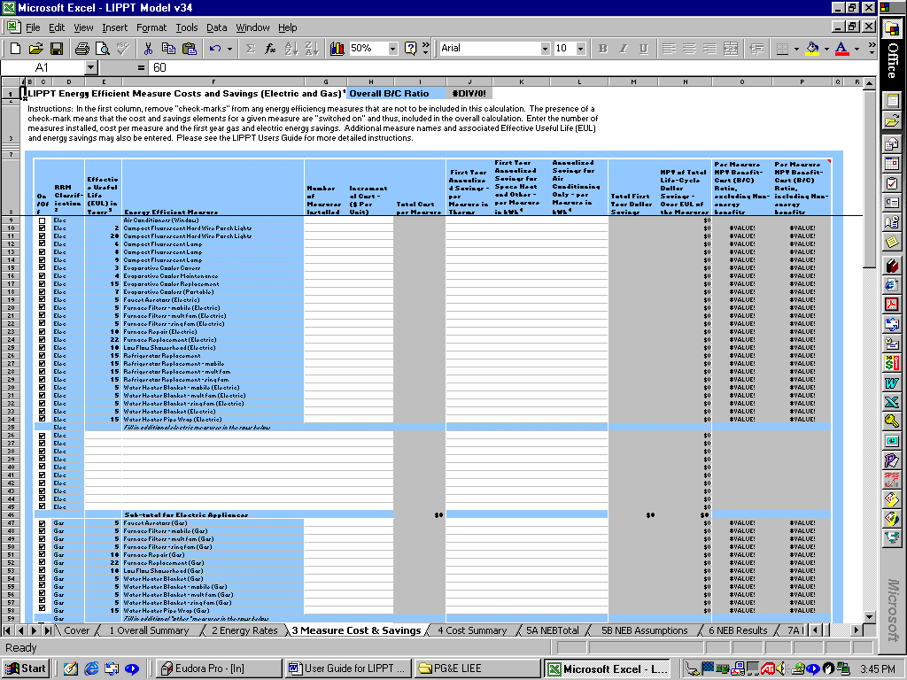

Figure 3 Worksheet 3 Measure Cost & Savings

Worksheet 4 Cost Summary
Figure 4 illustrates the 4 Cost Summary worksheet of the model. This worksheet is where all non-measure program costs are recorded. The first three cost categories included in this worksheet are brought over from the 3 Measure Cost & Savings worksheet to allow the user to see the measure specific costs while they are recording the program operations costs. The three measure cost categories automatically filled on this Worksheet are the electric measure costs, the gas measure costs and the weatherization measure costs. These are the first 3 cost elements listed in on the worksheet. The additional cost categories listed on the 4 Cost Summary worksheet need to be filled in by the user.
As in the 3 Measure and Cost Savings worksheet previously discussed, Column C of 4 Cost Summary worksheet contains a switch. This switch is located on the right-hand side of the worksheet and can be turned “on” or “off” (See Figure 4) to allow the user to include or exclude program costs in the calculation. This allows the user to see the impact of including or excluding program operations costs in the LIPPT calculation. However, care should be exercised in making program design consideration by examining the impact with the inclusion or exclusion of program costs in the LIPPT. Changes in program operations budgets can impact the success of the measure installation efforts and have a significant impact on the number and type of measures installed in a program. For this reason, the LIPPT users should not automatically conclude that the benefit cost ratio will project what will happen at the program level when a cost is included, excluded, increased or decreased in this test.

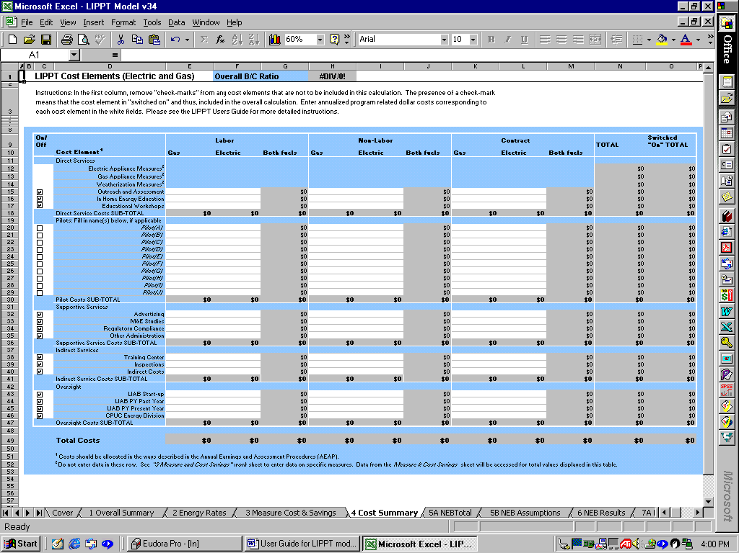

Figure 4 Worksheet 4 Cost Summary
When a cost element is switched “on” a check mark (3) appears in column C, when the cost element is switched “off” the check mark is not present. By default, all costs are switched on. When a cost is switched “on,” the cost element is included in the benefit-cost calculation. Accordingly, Column N displays the total of all cost elements, (regardless if they are switched “on” or “off”), and Column O displays only the total for the cost elements switched “on.” Those that are switched “off” appear as $0 in Column O.
Column D lists the program operations related cost elements and groups them into four categories, including:
- 6 direct service elements (Electric, gas appliances, weatherization measures, outreach and assessment, In-Home Energy Education, and educational workshops),
- 10 fields for recording program associated pilot programs,
- 4 supportive service elements (Advertising, M&E studies, regulatory compliance, and other administration),
- 3 indirect service elements (Training Center, inspections, and other indirect services), and
- 4 oversight elements (LIAB start up, past year and present year and CPUC Energy Division).

The above cost elements require data entry for those costs that apply to the program being tested by the model. Costs that do not apply to the test should be left blank or entered, but switched “off” and thus excluded from the calculations of this model. Please see Table 1 below for a definition of each of these ‘Cost Elements.’

Table 1 Cost elements and definitions
Cost Element | Definition of cost element
Direct Services
Electric Appliance Measures | Costs related to electric appliance tune-up, repair or replacement, but not inspections. See 3 Measure Cost & Savings worksheet to enter data and see details.
Gas Appliance Measures | Costs related to gas appliance tune-up, repair or replacement, but not inspections. See 3 Measure Cost & Savings worksheet to enter data and see details.
Weatherization Measures | Costs related to weatherization measures, but not inspections. See 3 Measure Cost & Savings worksheet to enter data and see details.
Outreach and Assessment | Costs associated with community outreach or program promotion, excluding “In-Home Energy Education and Education Workshops.”
In-Home Energy Education | Costs for conducting in-home education efforts for the LIEE program.
Educational Workshops | Costs for organizing, recruiting customers for, and/or conducting education workshop efforts.
Pilot A through J | This table provides space for up to 10 pilot programs. The pilot programs are typically test program implemented as part of the program being evaluated in the LIPPT.
Supportive Services
Advertising | Costs for advertising or mass media promotion of the program (TV, radio, newspaper).
M&E Studies | Any measurement and evaluation costs that are attributable to the LIEE program.
Regulatory Compliance | Costs related to compliance of regulatory issues, and may include utility law department, testimony, and supervisory effort for regulatory issues.
Other Administration | Additional administration costs allocated to the program not covered by other categories.
Indirect Services
Training Center | Costs attributable to the LIEE program for training center activities and/other services to train and certify LIEE implementers.
Inspections | Costs for pre- and post-inspections associated with installation of measures for the LIEE program.
Other Indirect Costs | Indirect costs represent the overhead costs of operations based on allocation in proportion to program effort across program type.
Oversight
LIAB Start-up | Costs by the LIAB required to oversee the program start-up efforts.
LIAB PY Past Year | Costs by the LIAB required to oversee the program efforts that have carried over from the LIAB previous year.
LIAB PY Present Year | Costs by the LIAB required to oversee the LIEE program efforts.
CPUC Energy Division | Costs by the CPUC Energy Division required to oversee the LIEE program efforts.

To complete the 4 Cost Summary worksheet, the user needs to enter program operational related costs corresponding to each ‘Cost Element’ in Column D. Cost field for which the program has no costs in that element should be left blank.
The costs elements included in the Worksheet are divided into three cost categories consistent with California’s current program cost tracking reports. These are, ‘Labor,’ ‘Non-Labor,’ and ‘Contract’ costs. See Table 2 below for the definition of these categories. Costs should be allocated in the same way regardless of fuel type (gas or electric), in a manner consistent with the Annual Earnings and Assessment Procedures (AEAP).
Labor costs are further segregated into sub-categories in columns E and F by fuel type (gas and electric respectively). Labor costs from columns E and F are added together in Column G. Similarly, Non-labor costs are segregated by fuel types in Column H and I and added together in Column J. Contract costs are segregated by fuel type in Columns K and L and added together in M. The Labor sub-total (column G), Non-Labor sub-total (column J), and Contract sub-total (Column M) are added together in Column N. Column O (‘switched “On” TOTAL’) is simply the value of Column N, if the costs for that element is switched “on.” If the cost element is “switched off” the switched off column O is $0 to indicate that the cost is not included in the calculation.

Table 2 Definitions of labor, non-labor and contract costs
Labor | Any internal direct (administrative and/or implementation) costs, unburdened by overhead, that represents person hours.
Non-Labor | All direct internal (administrative and/or implementation) costs not covered under labor. Any flyers or other literature that go out with the program are included in this non-labor category.
Contract | All outsourced costs (administrative and/or implementation). Outsource or “contract” costs do not need to be further broken out by labor/non-labor or administrative vs. implementation. This category includes contractor employees.

Structure of the NEB Worksheets of the Model
The following sections of the user’s guide provide basic instructions on the operation of the non-energy benefits (NEBs) worksheets of the LIPPT model. Worksheet 5A NEBTotal displays the value of total program-wide NEB benefits along with the program name and utility name. No data entry is required.
There are 2 worksheets that follow 5A in which users need to make data entries for the estimation of NEBs. These 2 worksheets (numbers 5B and 6) include virtually all the information most users need to establish NEBs for the model, and these are described as:
- The summary worksheets of inputs and assumptions for the program design and NEB selections (worksheet 5B NEB Assumptions)
- Worksheet 6 NEB Results is a summary worksheet showing the results of the NEB proxy results for the program. This worksheet summarizes the results from all three perspectives from which the non-energy benefits are analyzed: 1) utility and ratepayer; 2) societal; and 3) participant.

In addition to these 3 worksheets, there are 26 detailed worksheets that allow the user to change the underlying NEB assumptions from default values. No changes or data entry is required in these 26 worksheets. The 26 detailed NEB worksheets include:
- Eleven worksheets performing the detailed calculations for each “utility / ratepayer” NEB category (numbered Worksheets 7A-7K)
- Four worksheets performing the detailed calculations for each “societal” benefit category (numbered Worksheets 8A-8D)
- Eleven worksheets performing the detailed calculations for each “participant” benefit (numbered Worksheets 9A-9K)
In addition, there are 5 more worksheets that illustrate graphical outputs on NEB results. These are worksheets 11A-11F.
One data entry worksheet, confidential, detailing the utility-specific inputs for various cost and occurrence categories is entitled CONFIDENTIAL-UtilNEBDataInputs. This is the last worksheet in the model, appearing after 12 NEB and Measure Ratios.

- Regardless of perspective or benefit category, each of the 26 detailed NEB worksheets including detailed computations is constructed in generally the same manner

Further explanation of the various types of data inputs, and the color-coded fields where they are entered are summarized in Table 3 below.

Table 3 Format of the NEB Worksheets
Type of Entry | Color-coded location of entry
California frequency of occurrence of a Benefit-related item (usually from California utility or other source) | Red text value: Usually not entered by user directly, but fed from the Worksheets of data previously supplied by the utilities. If the data were derived from program assumptions the text will be blue (for example, expected kilowatt hours saved by the program).
Expected change in occurrence expected from the program | Yellow highlighted area: If the user wants to change the selected value, a different check box in the associated yellow table is selected. For some NEBs, the change in incidence is not known, or the computation takes a different form that skips this step.
California cost or value associated (depending on perspective) | Red, blue, or black text, depending on its source (respectively, California data, program assumptions table, or other sources). These are generally not changed by the user, but reflect valuations like marginal utility cost per call, minimum wage, or other values associated with the particular NEB.
Interim Non Energy Benefit Proxy Value | Black text: Computed from the preceding values. The computation is described in the Worksheet.
Annualizing Factor | Blue text: This figure is derived from program and scenario-related assumptions. It is a payment function value derived from the 1) time horizon for the individual program; 2) discount rate for the perspective (entered from the program assumptions); and 3) the program evaluation horizon.
Estimated Proxy Dollar Value of Non-Energy Benefits Value in Annual Terms | Black text: Proxy calculated Non-Energy Benefit, in an annualized stream in terms of dollars per participating household

The NEB portion of the model focuses on computing the annualized in terms of the average dollar value of non-energy benefits per participating household in the following manner:

(NEB Value) = (Frequency of Benefit) x (Change in occurrence) x (Value)

(Annual Dollar Value of NEB) = (Non Energy Benefit Value) x (Annualizing Factor)

Worksheet 5A NEB Total
Worksheet 5A NEB Total displays the program name, utility, and overall NEB benefit values. This worksheet requires no data entry. See Figure 5 below.

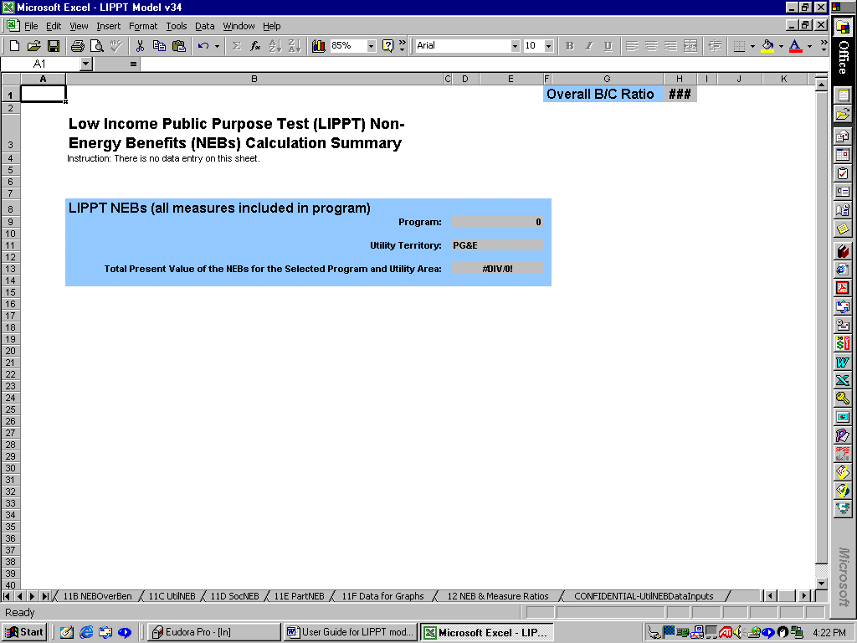

Figure 5 Worksheet 5A NEB Total

Worksheet 5B NEB Assumptions
Low Income Energy Efficiency (LIEE) program assumptions used in the calculation of NEBs are set in two locations: worksheet 5B NEB Assumptions (which is the assumptions for the costs and benefits section), and on worksheet 6 NEB Results.
The 5B NEB Assumptions worksheet (Figure 6 below) contains a number of assumptions set by the user and incorporated into the computations on the NEB worksheets. The user sets the items in the white areas; the gray areas are computed or transferred from other entries in the model. Key items users need to review and accept or change and enter include:
- ‘Percent on CARE’ - Enter the estimated percent of households participating in the program that is assumed to be CARE recipients.
- ‘Rebate provided’ - Enter the dollar value of the average rebate per participating household.
- ‘Program horizon in years’ - Enter a number (usually 20 years or less) that represents the number of years over which the LIPPT test is to be conducted – the horizon over which the benefits will be valued.
- Cost and number of CO monitors installed - Enter the dollar cost of equipment and labor for installing, along with the number of CO monitors installed. This should be the average installation and equipment cost for the homes in which this measure was installed (an associated field requesting the percent of homes that CO monitors were installed in is juxtaposed). Note: Because California LIEE programs do not install CO monitors, this should be set to zero (0).
- ‘Cost of other health and safety measures’ - Enter the installed cost of other health and safety measures that are put in place through the program. Again, the cost should be the average for homes that had the measure installed. A factor that addresses the share of homes with the measures installed is entered on the right hand side of this page. Heath and safety measures refer to items that might help prevent fires or prevent other health and safety related crises.
- ‘Average cost of household repairs’ - Enter the average cost of home repairs for homes that had repairs. This should not include addition of insulation or other items related to directly to energy-savings.
- ‘Discount rate for utility benefits’ - The interest rate should reflect the one used by the utility as the discount rate reflecting their time value of money. This value is used in annualizing utility-related benefits.
- ‘Discount rate for societal benefits’ - This interest rate should reflect the discount rate for benefits from a societal point of view. This rate would generally be lower than utility discount rates, reflecting the longer payback requirements for societal investments. Again, it is used for annualizing societal benefits.
- ‘Discount rate for participant benefits’ - This interest rate should reflect the discount rate for benefits for participants. This rate would generally be higher than utility discount rates, reflecting the fact that participants, particularly low income customers face higher interest rates for borrowing, and do not have the funds to wait for long paybacks.
- ‘Minimum wage per hour’ - Current minimum wage in California is $6.25 per hour, increasing to $6.75 per hour in 2002. As this changes, the new value should be entered.
- There is a check-box displayed just below the minimum wage field. Only uncheck this box, if utility data in the CONFIDENTIAL UtilNEBDataInputs worksheet has been updated from the data originally put in there in April of 2000. If unchecked, this will inflate certain underlying NEB data to reflect new time periods.
- Adjustment factor for programs with less energy savings - When the lower most check-box on the worksheet is switched on, the model is adjusted for programs with less savings than what is expected from a “typical weatherization program.” This occurs when annual per participant combined gas and electric energy savings is “significantly” less than the dollar amount entered in the cell just below the adjustment factor check-box. This is called the ‘Per household energy savings threshold adjustment factor,’ and the default value is $175 of annual energy savings. When programs save this amount or more, the scaling factor has no effect. However, when annual program savings are less than $175, the value of energy savings dependant NEBs can be scaled down by the ‘Calculated pivot ratio.’ The pivot ratio is displayed to the right of the check-box, and is calculated by taking the actual program energy savings and dividing it by the threshold adjustment factor ($175).
- ‘Percent of ALL participants with measures installed’ are displayed over to the right and near the top of the worksheet. These percentages should be computed as the total of all participants that had the measure installed divided by the total number of participating households. This holds for gas, electric, and gas and electric measures – in all cases the number of homes with measures installed should be divided by ALL participating homes, not just by gas or electric homes. These percentages are used in conjunction with the entries on the left side of the page reflecting the number or cost of items installed in homes that had the measures installed. In cases in which the user does not have information on the percent of homes with measures installed, the user should compute the average number of measures installed across ALL households and put that figure in the relevant columns in the left side (e.g. average CFLs installed, aerators installed) and enter 100% for the percent of homes with the measure installed in the right hand columns on the page. It is very important for the operations of the model that these percentage fields be populated. If they are not populated the NEB will not be accurately projected.

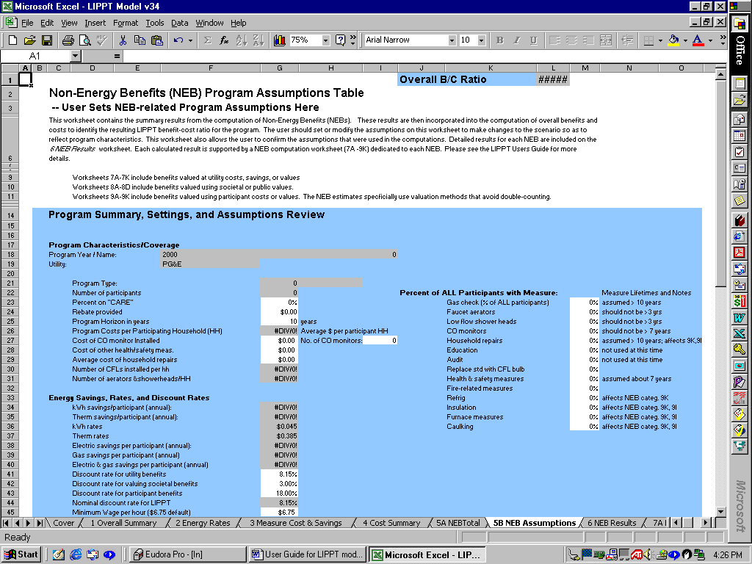

Figure 6 Worksheet 5B NEB Assumptions

Worksheet 6 NEB Results
The values of the benefits for the NEBs are summarized in worksheet 6 NEB Results. Annual benefits are presented in the furthest right gray-colored - Column O. These values are used to compute the NPV figures, (furthest left gray-colored - Column K). These values are adjusted for the scaling threshold discussed above and the NPVs are used in the computation of the Overall Summary of LIPPT cost effectiveness test results. Column P displays the annual benefits unadjusted for the scaling factor.

The ‘Total Program Horizon from Assumptions above’ (Column J) are in blue-colored column just to the right of the white column and the “check-box” selection switch (far left) allow user to select which benefits should be included or excluded. Here benefits can be switched on (with a check-mark) or switched off by clicking the check-mark away, so that it disappears. The ‘Non-Energy Benefit Category’ itself is displayed across columns E-H. The only column requiring manual data entry is the white-colored one (Column I), which displays the number of years each NEB is expected to last. Worksheet 6 NEB Results includes the NEBs from the utility, societal, and participant perspectives.

- Far right on table: User “checks-marks” boxes to indicate which benefits should be included in the computation. When a benefit is “unchecked,” a value of “0” is included in the NPV for that benefit, and the two gray-colored columns “zero out” accordingly.
- White column: User enters the number of years over which the benefit is expected to last (time horizon). The user enters the best estimate of these years. Some of the benefits might be expected to parallel the energy savings; others would be expected to be one-time benefits (user should enter a 1 in that case). For example, fire-related items were set to “1”. In other cases, measure lifetimes help determine the years; CO monitors last 7 years, and aerators are expected to remain in place about 3 years. These values are translated to the individual NEB worksheets to annualize the values.
- Blue column just right of white column: There are time horizons selected on the initial worksheets of the LIPPT model and used to compute net present values from the annualized NEB streams.
- First gray-colored Column K (left-hand one): This is the NPV of the individual NEB benefit. The sum of these benefits is used in the computation of the LIPPT test.
- Middle gray-colored Column O: Computes annual per participant values from Column P and adjusts them with the adjustment factor, (if checked) for programs with fewer measures and less energy savings.
- Furthest right-hand gray-colored Column P: Computed individual NEB annually for all participants, transferred over to this Worksheet from the 25 individual NEB calculation Worksheets.

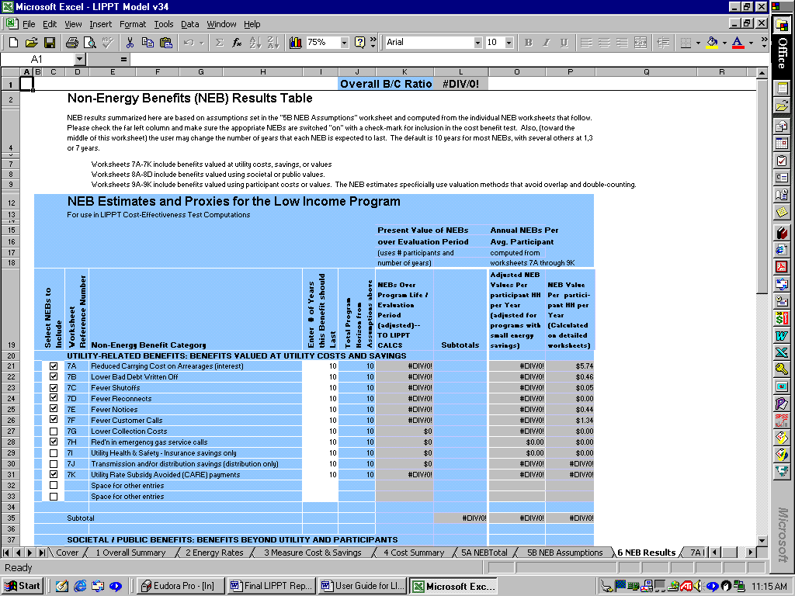

Figure 7 Worksheet 6 NEB Results

Table 4 below displays a listing of NEB detailed worksheets and corresponding worksheet numbers. The table includes a brief comment on each NEB and the default setting of the “on/off” switch for “inclusion or exclusion” in the cost benefit test. NEBs switched “on” are listed as “included” and NEBs switched “off” are listed as “excluded” in the table below.
Table 4 LIPPT Non-energy Benefits
Detailed Non-energy Benefit | Worksheet number | Default Setting (Included or Excluded) |  | Comments
Utility associated benefits
Reduced carrying costs on Arrearages | 7A | Included | Only counts the utility savings on financing the arrearages, not the arrearage reduction itself
Lower bad debt write-offs | 7B | Included | Only counts the savings associated with a reduction in the level of debt that is written-off as a loss and placed in the rates
Fewer shut-offs | 7C | Included | Includes the utility savings for a reduction in the number of shut-offs
Fewer reconnections | 7D | Included | Includes the utility savings associated with fewer reconnections
Fewer notices to the customer | 7E | Included | Includes the incremental savings associated with a reduction in repeat customer collection notices
Fewer customer calls | 7F | Included | Includes the savings associated with a reduction in telephone calls associated with debt collection
Lower collection costs | 7G | Excluded | Includes the reduction in collection costs that are not covered in other categories, if any
Reduction in emergency gas service calls | 7H | Included | Includes savings associated with not making emergency calls to customers, if the program has emergency reduction measures
Utility health and safety – insurance only | 7I | Excluded | Not currently available from utilities
Transmission and distribution | 7J | Excluded | Includes line loss savings associated with not needing to distribute the energy saved.* Already included in the energy rates for avoided utility costs
Avoided utility rate subsidies | 7K | Included | Includes the CARE program
Societal associated benefits
Economic impacts | 8A | Excluded | Included in the test, but set to zero until more rigorous studies document net impacts
Emissions reductions and environmental impacts | 8B | Excluded | Includes the value of pollution not produced associated with the energy savings, already counted in the energy savings rates for utility avoided cost
Improved health and safety | 8C | Included | Benefit for CO detectors and other safety measures to society
Water and waste water | 8D | Included | Includes only the avoided costs associated with the water savings to the water provider
Participant associated benefits
Water and waste water | 9A | Included | Includes the participant savings, excluding the avoided cost savings counted in the societal benefits
Fewer shut-offs | 9B | Included | Includes the participant savings associated with not having as many shut-offs
Fewer calls to the utility | 9C | Included | Includes the participant savings associated with reduced problem calls to the utility
Fewer reconnects | 9D | Included | Includes the participant savings associated with few reconnections after shut-off
Property value benefits | 9E | Included | Included only if the program makes property improvements beyond energy savings measures
Fewer fires | 9F | Included | Includes the savings to the participant associated with a reduction in home fires as a result of the program
Heath and safety – CO Monitors | 9G | Included | Includes the cost savings associated with reduced illnesses and death associate with CO detectors, if installed
Moving costs | 9H | Included | Includes the savings with not having to move from a home as a result of shut-offs and higher energy bills
Reduced participant Illness, fewer sick days from work | 9I | Included | Benefit derived from lost wages avoided from sick days at work
Reduced transaction costs | 9J | Excluded | May not be appropriate for low-income and the measures installed
Comfort, hardship, etc | 9K | Included | Valued from customer surveys indicating what they would pay for the benefits received
* This may be dropped from test, as it may be already included in the participant savings

Worksheets: 7A-7K, 8A-8D, and 9A-9K – Detailed NEB Computation Worksheets
Each worksheet of the detailed NEB computation worksheets (7A-7K, 8A-8D, and 9A-9K) resemble the example shown in Figure 8. The example provided in this figure, which computes the results for a sample NEB (from reductions in Bad Debt written off), includes the following items, and each worksheet that follows has a detailed NEB computation worksheet that is set up in a similar way. Tables displayed on each of the NEB detailed worksheets contain some or all of the common items.

- Step or “Item Number” (Column B)
- Computation description for each entry or item number (Column I)
- Source for the numbers in each step or item number (Column J)
- Interim proxy value before “annualizing”. The computation method to derive this term referencing the specific item numbers and what part they take in the computation (Displayed as the yellow-shaded field in the blue tables)
- Horizon (time) period used for the individual benefit
- Factor for “annualizing” the benefit, and
- Final proxy value, annualized in per participant terms (Displayed as the red-colored cell in the blue tables).

Text, field, table, and check box colors are meaningful on each worksheet in the following ways:

Text Colors
- Red text: Red text indicates that the item or entry is from California-specific data. These data may be provided by the utilities, from official filings, or from other California studies.

- Blue text: Blue text indicates that the item or entry is from NEB assumptions made for program analysis scenarios.

- Black Text: Indicates the value is computed or is an interim value, or is not from California (red text) or program summary (blue) sources.

Field Colors
- Yellow Field: Data in a yellow highlighted area indicates an entry specifically selected by checking a box in the accompanying yellow table (see Figure 8).

- Red Field: The final annualized NEB value that is transferred to “6 NEB Results” worksheet is highlighted in a red box. On each detailed NEBs worksheet, this red number is selected for inclusion in the final computations. This is assuming that it is checked off on the check boxes on Worksheet 6. If selected, the time horizon and discount rate assumptions are used to compute the net present value (NPV) for the individual benefit (contained in column J on “6 NEB Results”). The sum of the included NPVs is transferred to the “1 Overall Summary worksheet.”

Table Colors
- Yellow Table: The yellow table displayed to the right on most NEB detailed worksheets is used to organize data available from published studies on impacts from similar low-income programs. The yellow boxes include: 1) “check boxes”, only ONE of which should be selected by the user (see the next bullet for additional description); 2) the “value” from the study; 3) the citation for the associated study; and 4) a description of the basic information underlying the value. Each yellow box includes the average, median, minimum, and maximum value for the range of values. Any of the values in the yellow table may be selected.
- Blue Table: The blue tables (to the left on each NEB detailed worksheet) are the main table for each individual NEB.
- Golden (Orange) Table: The Golden colored (Orange) are similar to yellow tables except that instead of check-boxes, the golden tables allow for manual entry of numbers into the white fields of the golden tables. However, no change to the default values (contained in the white fields of golden tables) is required. Golden tables are displayed to the bottom right on some NEB worksheets.
Check Box
- Check boxes: The white areas with check boxes allow user selection of the preferred or most appropriate value for NEB impact (the change in incidence) that is attributable to the program. Only one check box may be selected on these tables, or an error message is displayed.

The source for the data entries, the computation methods, and the meaning of the data entries are all explained in the blue fields of each worksheet and default values are already selected. It is recommended that the user review entries in NEB Worksheets, however, default values have already been selected and no data entry is required on any of the following sheets.

Worksheets: 7A, 7B, 7C, 7D, 7E, 7F, 7G, 7H, 7I, 8C, 8D, 9A, 9E, 9H
NEB worksheets in this grouping have one blue table (to the left) and one yellow table (to the right). No data entry is required here. Most of the data to support these computations comes from previously entered data and assumptions. A default value is specified for the size of the impact of the program on the benefit. This value is “checked” in the yellow table, and the selected value is transferred to the yellow cell in the blue computation table. However, more advanced users may select another value by de-selecting the default impact value (denoted by the check box shaded in blue) and then selecting another value. This changes the NEB value from the default value to other selected values. See Figure 8 below for an example of this kind of NEB worksheet.

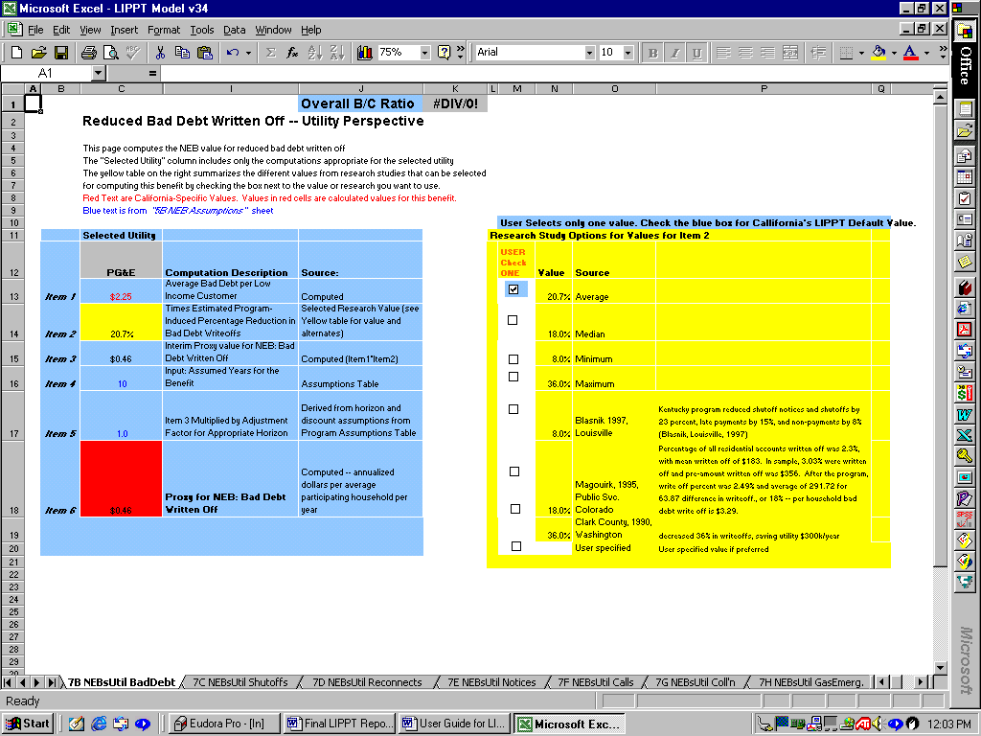

Figure 8 Worksheet 7B NEBUtil BadDebt

Worksheets: 8A, 9B, 9D, 9F, 9G
NEB detailed worksheets in this grouping have one blue table (to the left) and two yellow tables (to the right). Data to support these computations come from previously entered data and assumptions, and no data entry is required on these worksheets. The consultants designated default values for these entries where data were available; however several are blank, and if the user has access to appropriate data, the user can directly enter it. The consultants also specified default values for the size of the impact of the program on the benefit. This value is “checked” in the yellow table, and the selected value is transferred to the yellow cell in the blue computation table. The model allows the user to select another value for this impact by de-selecting the default impact value (denoted by the check box shaded in blue) and selecting another value. Only one value maybe selected at a time.
Figure 9 is the first illustrated example of one that contains a gold (orange) colored cells and tables. As discussed above, Gold (orange) cells require no data enter, and are driven by the white cells of the gold (orange) tables located at the bottom of the worksheets. The gold tables allow for, but do not require, data entry. Gold tables allow for certain adjustments to assumptions about NEBs and appear on worksheets 7I, 8A, 8D, 9B, 9C, 9D, 9F, 9G, 9H, 9I, 9J, and 9K.

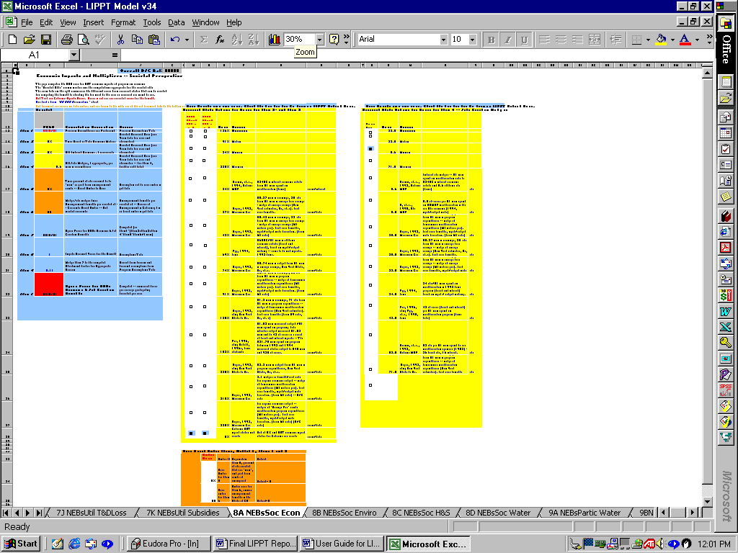

Figure 9 Worksheet: 8A NEBsSoc Econ

Worksheets: 7J, 8C, 9G.
NEB detailed worksheets in this grouping have two blue tables (to the left) and one yellow table to the right. For NEB worksheets in this grouping, have included two alternate computation methods, one of which is the preferred default value. The user may review the two proposed methods. If the alternate computation method is desired, the user replaces the number in the “WHITE CELL” labeled “USER Select computation Method 1 or 2”, and enters the number designating the preferred computation method. All numbers will then recomputed and feed into the net present values totals for the NEBs. One and only one value should be selected (with a check-mark) in the yellow table. However, no data entry is required because the default setting is already selected.
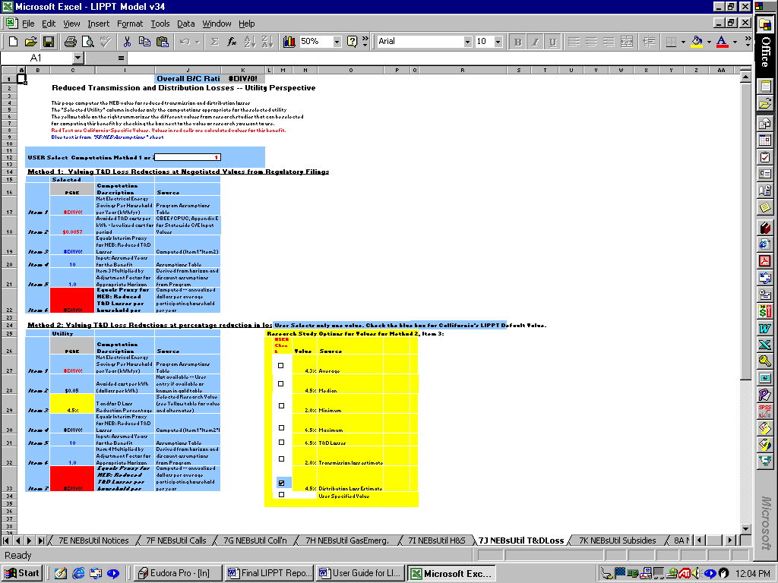

Figure 10 Worksheet 7J NEBsUtil T&DLoss

Worksheets: 7K, 8B, 9C, 9I, 9J
NEB detailed worksheets in this grouping contain a single blue table. No user changes or data entry is required or possible on these worksheets.

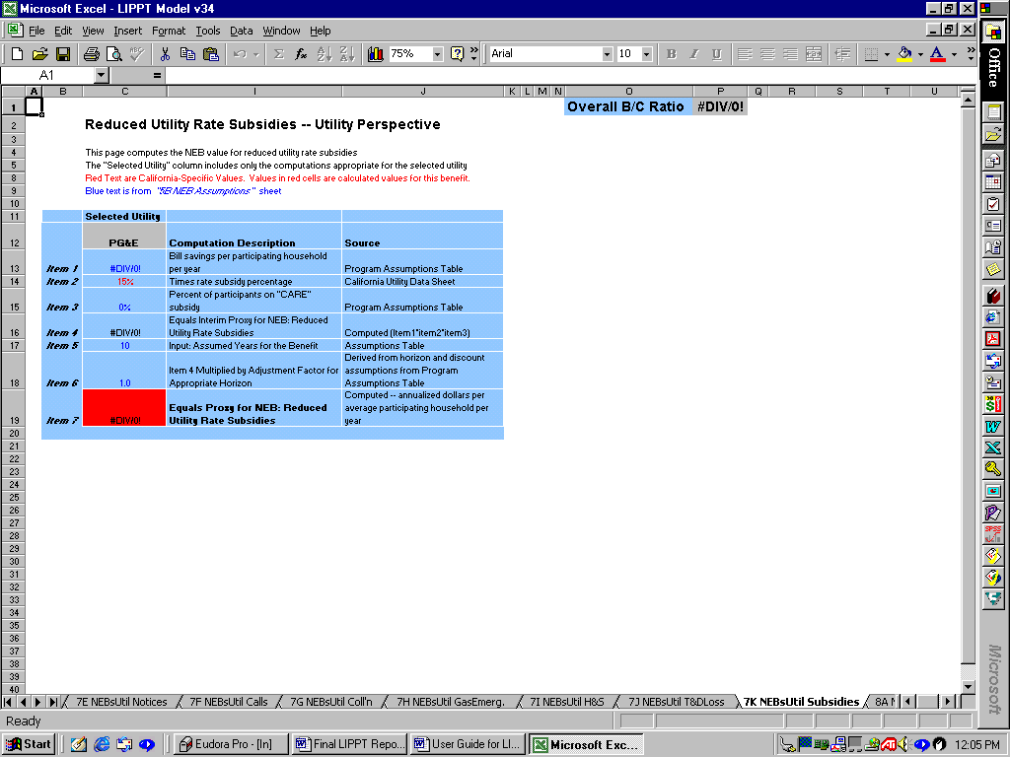

Figure 11 Worksheet 7K NEBsUtil Subsidies

Worksheet 10 Measure Benefit Archives
The 10 Measure Benefit Archives is a protected worksheet and does not require data entry. This worksheet contains California utility historical energy savings data for energy efficient measures that can be used to assist the user in determining what energy values to enter into the 3 Measure Cost & Savings worksheet. The data on this worksheet is for display purposes and does not drive calculations in this model.
For each measure, first year gas savings (in Therms) and first year electricity savings segregated for “Space Heat and Other” and “AC Only” are displayed for the four California utilities (See Figure 12 below). The columns for each utility are as follows:
- Columns G, H & I (PG&E)
- Columns J, K & L (SoCalGas)
- Columns M, N & O (SCE)
- Columns P, Q, & R (SDG&E)
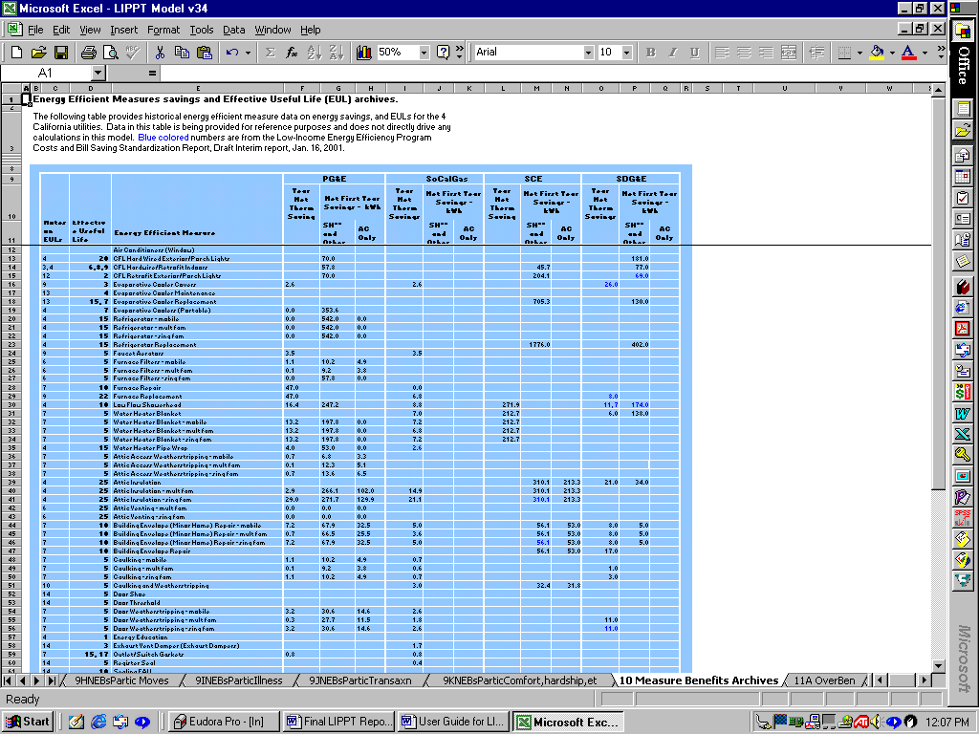

Figure 12 Worksheet 10 Measure Benefits Archives

Worksheets: 11A-11F
Worksheets 11A through 11F require no data entry. These worksheets display graphical outputs that illustrate results of the cost benefit test. Each graph illustrates the following:
- 11A OverBen: Pie graph illustrating the relative portion of overall benefits attributable to utility, ratepayer, and society and energy benefits
- 11B NEBOverBen: Bar graph illustrating the per participating household dollar value benefit for utility, society, and ratepayers
- 11C UtilBen: Pie graph illustration of utility NEBs
- 11D SocNEB: Pie graph illustration of society NEBs
- 11E PartBen: Pie graph illustration of participant NEBs

The worksheet “11F Data for Graphs” stores all the data generated from the model used in generating these 5 graphs and is automatically updated. If a worksheet has no graph displayed on it, that means that the benefits in that category are zero.

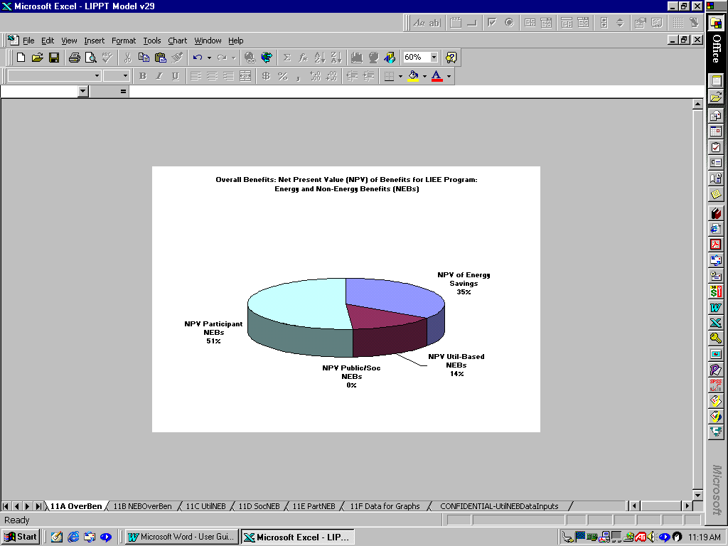

Figure 13 Worksheet 11A OverBen

Worksheet 12 NEB & Measure Ratios
The calculations on worksheet 12 NEB & Measure Ratios distributes the NEBs across each energy efficient measure for the purpose of developing measure-specific benefit-cost ratios and includes both energy and non-energy benefits. Each of these measure vs. NEB relationships is assigned a value of “1” or “0.” A “1” is entered for those NEB & measure relationships where the measure has at least some impact on the NEB. Alternatively, a “0” is assigned to those relationships were the Measure has no impact or a negative impact on the NEB.
The calculations on this worksheet have no bearing on the overall Benefit-cost ratio of the model, and it is only necessary to enter new data (0s or 1s), if new measures are added to worksheet 3 Measure and Energy Savings. If new measures are added to worksheet 3, they will automatically display in column F of this worksheet. When this occurs, the user needs to enter a “1” or “0” in the white areas to the right of the new measure name displayed in Column F. This will allow the model to reallocate and compute a measure specific benefit-cost ratio for all measure, taking into account the added measures.
The column headers of worksheet 12 are labeled with specific NEBs. When entering data for added measures, it is advisable to look at similar measures for which data already exists (blue colored) to aid in selecting which NEBs are impacted by the added measures (“1”) and which ones are not (“0”).
When data entry is completed for added measures, the user may refer back to Worksheet 3, Column P to view the added measure benefit-cost ratios that include the newly updated allocation of NEBs.

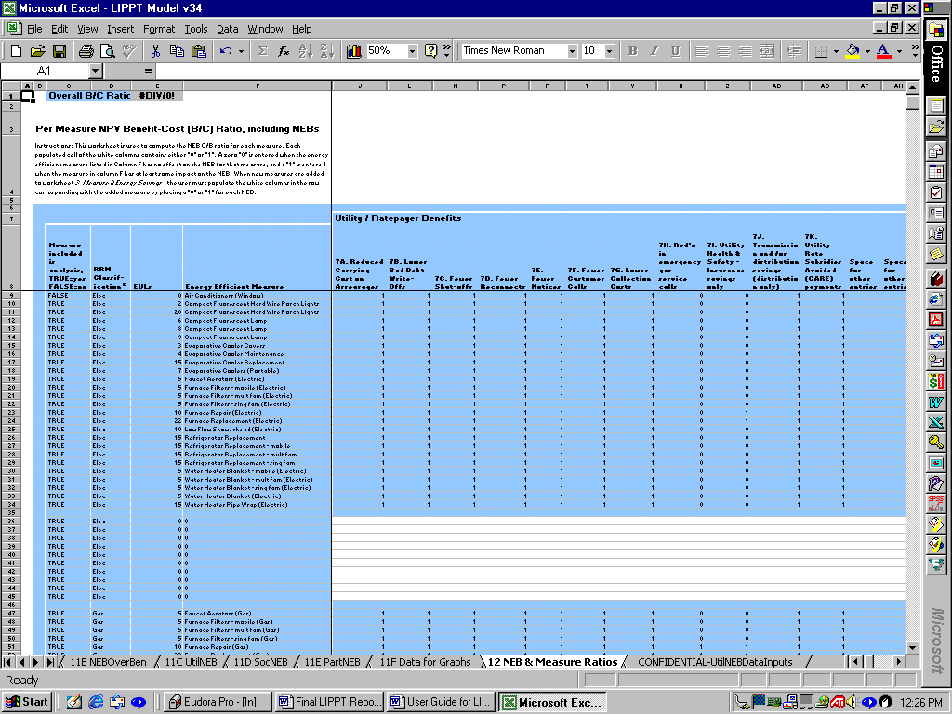

Figure 14 Worksheet 12 NEB & Measure Ratios

Worksheet CONFIDENTIALITY UtilNEBDataInputs
Utility specific data is contained on the CONFIDENTIAL UtilNEBDataInputs worksheet and does not need to be viewed in order to run the model. Information on this worksheet is password protected to maintain utility confidentiality. Users are not to attempt to view this worksheet without permission from the four participating utilities. The data on this worksheet is business confidential.

NEBs Appendix

Terms and Units: What is Being Computed
One of the most confusing aspects of previous work in NEBs is the difference in the units in which the benefits are measured. In previous work, some categories of benefits were presented in present value terms, others in annual terms, and so on. This has made it difficult to identify which benefits are large and which are small. The NEB computations included in this work is different and follows the convention of previous work by the consultants by presenting all benefits in the same terms – estimated annual benefits for an average participating household – not a mixture of present values, annual, and one-time benefits. Benefits can then be compared easily, and computations can be uniformly applied for increases in participants, changes in time periods, etc.

The literature has presented this type of work in both dollar terms and percentage adder terms. Given that the goal of this project is a revised cost-effectiveness test, we select dollar terms (annual and net present value) as the units for these estimates.

Time Horizons for the Benefits – Annualizing and NPV
It is crucial for the user to understand that there are two “year or horizon” values that are used in the computations. One represents the number of years we expect the particular benefit to last, and the other represents the time period over which the program is being evaluated.

In some cases, benefits may be hypothesized to occur annually. Energy savings is one example of this type of benefit. Others benefits can only last as long as the retrofit or measure lasts. Water savings or CO monitor impacts are examples of these benefits. For the case of water savings, the water conservation literature and interviews conducted by the consultant find that most of the faucet aerators and showerheads can be expected to have lifetimes closer to three (3) years. Carbon monoxide monitors have a useful life of approximately seven (7) years. For this reason, we have set the horizons for benefits related to these measures to be three and seven years, respectively.

For some other benefits, professional judgment may be involved. Some argue that reductions in arrearages would last as long as the energy savings – after all, the reductions in energy bills remain as long as the energy savings lasts, continuing to help residents avoid arrearages and payment difficulties. Others argue that the bill, payment, and shut-off related benefits should only be counted for a few years.,, Default values for these horizons were included in the original settings for the model. We used the default settings that the benefits occur annually for ten (10) years for all benefits with two the following exceptions, both of which are hardware-related:
- Three (3) year horizons for water-related benefits, and
- Seven (7) year lifetimes for carbon-monoxide-monitor benefits.

The report also shows the difference in results when some other bill-payment related benefits are assumed to occur over a 10 year horizon vs. 5 years. This can be explored and selected by the user.

DATA ENTRY LOCATION for Benefits Horizons: These horizons are entered in the white area on the lower parts of Worksheet 6 NEB Results. In each case, default values are already entered. See Table 2 in this document for further explanation of these entries.

Deriving Net Present Value

The benefits needed for the LIPPT need to be in total NPV terms. This requires the use of two horizons, as well as discount rates. The first horizon, which we have discussed (the number of years we expect the specific benefit to last), is used to translate benefits that may accrue for differing periods of time to comparable annualized benefits.

In annualizing these computations, we have applied perspective-related (i.e. participant, utility or societal perspectives) discount rates. These factors are transferred to all 25 detailed NEB Worksheets. We assumed that the utility benefits are discounted using 8.15% as the discount rate; societal benefits are discounted using 3%, and the participant benefits are discounted using a 10% discount rate (default values). These entries are described in more detail in Figure 1 of this document.

DATA ENTRY LOCATION for Discount Rates: These discount rates are entered on Worksheet 5 NEB Assumptions. In each case, default values are already entered.

The second time horizon term we need is the time period over which the program is being evaluated. This is the period that is applied when computing net present value numbers from the stream of annual benefits that we have computed using the methods described more below. This value is carried through for all the NEB computations.

The final items needed for the computations of the total NPV are the discount rate to be applied to the test (used to translate future benefits into present values), and the number of participants in the program. The overall discount rate used is a program assumption that can be changed as the user designs the scenario. The results presented in this section assume an overall LIPPT discount rate of 8.15%.

DATA ENTRY LOCATION for Discount Rate for Program Evaluation: Worksheet 2 Energy Rates. This same horizon is used to compute the NPV for all included benefits.

In summary, the computed proxy values for the NEBs are presented in terms of Dollar benefits in annualized terms per average participating household.

These values are presented for each individual benefit category on Worksheet 6 NEB Results and are translated into total NPV. The individual NPVs are summed and the total is transferred to the costs and benefits Worksheet to be used in computing the final benefit and cost results for the LIPPT.

More Information on Data Inputs
The computations of NEBs are based on several types and sources of data.
- Background Program Information: Background information on the proposed program design(s) for the LIEE program is needed for the computations, including participant characteristics, measures included, number of participants, etc. One key entry is for the utility territory being modeled.

DATA ENTRY LOCATION: These data are entered in white areas on the Assumptions Worksheet for the LIPPT costs and benefits.

- Utility Costs and Information: Utility-specific information on costs and benefits for a variety of important categories; for instance, carrying costs on arrearages, costs per call, fees for shutoffs, etc. This was gathered through a data request to the utilities and detailed in-house computations by the utilities to develop estimates of these factors. These values can vary for each of the utilities. In cases where all input information was not available for each utility, the researchers used averages or similar adjustments based on the data provided by other utilities.

DATA ENTRY LOCATION: These data were entered on 11 CONFIDENTIAL-UtilNEBsDataInputs worksheet. Data were requested from each utility, and the consultants used best judgment in adapting data to the specific entries needed for computing the NEBs.

- Estimates of Impacts/Reductions (Changes in “Incidence”): Each of the benefits categories uses information on the expected changes in the occurrence for program participants. For example, after program participation, what level of reduction in number of calls to the utility could we expect because bill payment difficulties would be reduced? This is the type of factor used to compute benefits categories from reduced utility / customer calls. These estimates were derived from sources we assessed to be the most appropriate for the LIEE programs.

DATA ENTRY LOCATION: These data are incorporated as “default” and “options” values on each of the 25 Worksheets (7A-9K) describing and performing the detailed computations of each category of benefits from the three perspectives (utility, society, and participant). Selections are made by checking boxes in white areas on these worksheets. In cases without dedicated data for the California programs, we have used and adapted data from documented research studies. These study values are included in yellow tables on the individual Worksheets (7A-7K, 8A-8D, and 9A-9K). The consultants have also identified default values representing conservative, defensible values for changes in reductions. These are noted by “blue-shaded” check boxes (default values are blue-shaded check boxes). Users with additional information or program designs that are better represented by other values for the change in incidence can easily select another research value by selecting another check box. Although, users may select other values for incidence impacts by selecting a different check box in the yellow tables, only one value may be checked at any time. Error messages will arise on the worksheets of the model next to data entry error if more than one value for change in incidence is checked.

- Estimates of “Value”: Each of the benefits categories uses information on the value associated with reductions in a particular activity or increases in a particular benefit. Values depend on the benefit and the perspective. For instance, values from the utility side may include the marginal cost of an activity, like gas emergency calls, bill payment activities, or other items. Participant benefits might use values related to wages or willingness to pay. Societal benefits use dollar values from a variety of sources, some negotiated and some based on avoided cost rates (water savings), and others as well. The sources or rationale for these values are explained in the individual NEB tables. For the most part, users would not change these values.

- Direct Data Entry: In some cases, direct data entry into white fields is appropriate. This includes the summary assumptions (described above), as well as incentive or value data for which the consultants could find neither strong data in the literature, or program-specific data. If users wish to include the benefit, they may need to define some of the values through direct entry.

On several NEB Worksheets ( i.e. 7I and 9G), the user is allowed to select between two alternative calculation methods. This is the case for two benefits for which there were different ways to compute the benefit. The benefits on worksheets 7I and 9G are both related to health and safety computations (from the utility and the participant perspectives, respectively).

Description of Computation Method for NEBs
The NEB portion of the model focuses on computing dollar value of non-energy benefits as Dollar value of benefit per average participating household per year.
The non-energy savings are treated in "per participant household" terms in all cases. This facilitates the scaling of the benefits up and down based on alternative program scenarios. Focusing on an annual stream makes certain that all entries are in the same terms and can be compared. Certainly, the benefits can easily be translated into other terms (including total program terms or percentage “adders”), depending on the analytical application.

Parameters related to the number of participants, anticipated impacts of program design or target audience changes, or other alternatives can be readily changed within the model, and the impacts on non-energy benefits from each of three separate perspectives (utility, society, and participant) can be analyzed and evaluated.

Following the same logic used in previous models and published research, the analytical approach is based on multiplying the potential value of a non-energy benefit times the expected change in incidence or occurrence in the factor based on program participation. The NEB portion of the model focuses on computing the annualized dollar value of the average dollar value of non-energy benefits participating household in the following manner:

California frequency of occurrence of a Benefit-related item
Times
Expected change in occurrence expected from the program
Times
California cost or value associated (depending on perspective)
Equals
Interim NEB Proxy Value
Times
Annualizing Factor
Equals
Estimated Proxy Dollar Value of Non-Energy Benefits Value in Annual Terms

NPV = Net Present Value
BTU = British Thermal Units
California Public Utilities Commission
Physical Year
For a detailed discussion on how NEBs are computed, please see the NEBs Appendix.
This “annualizing factor” is discussed in the appendix along with time horizons and net present value.
CARE is a California utility rate subsidy program
Please see the NEBs Appendix for a detailed discussion on Net Present Valuation (NPV).
Note: Societal benefits will always show up as zero benefits, as the LIPPT places these benefits into the cost savings for energy saved.
Op. cit.
An “adder” is an add on percentage to energy benefits or other benefits to account for a non-energy benefit.
One additional enhancement would be to reduce the energy savings (and related benefits) over time by the degree of technical degradation associated with the measures. This is a very appropriate and straightforward enhancement.
There are several reasons this assumption may be adopted. The studies that have been conducted on arrearages (as well as safety, and some other topics) tend to be one-year or one-time impact studies. It may be improper to assume that these benefits accrue year after year until the program’s measures reach the end of their useful lifetimes. Others note that the recipients move frequently, and low-income persons may not be the ones that reoccupy the “treated” dwelling
Users need to determine whether the benefits they want to measure from the program are only those accruing to low income customers, or those that accrue from a program designed to help low income customers, but that over time, may diffuse to some non-low-income customers. Other discussion items included concerns about whether programs that had the weatherization work conducted mainly by low income assistance groups or community-based organizations would be valued differently. Although this may be appropriate, there was insufficient information on differences between programs that did vs. did not take this approach to estimate different NEB proxies. In addition, many of those benefits would be economic-related, and (as the reader will discover) we have taken a very conservative approach on those benefits categories.
Others argue that the program may only be responsible for the one-time or short term assistance with bills, but that the consumers themselves are responsible for the continuation of good payment behavior.
In some cases, we have a benefit that is measured as a one-time benefit and essentially is a net present value in itself. In those cases, we have applied the discount rates and program evaluation lifetimes to turn the benefit into annualized terms, which are ultimately summed back up into the NPV, which is included in the LIPP Test.
Note that in some cases, we have incorporated best available estimates of the information needed. For example, the utilities may not have been able to provide the arrearages for low income customers specifically. In cases like these, we used the best information available, which was, the information for the average residential customer, as opposed to specific information for low income residential customers.
Skumatz, (1996), Skumatz and Dickerson (1997, 1999, 2000)
This annualizing factor is discussed earlier sections on time horizons and net present value.

