CALMAC Website Committee Status Report
to
CALMAC Meeting – 12/15/04

The following is a report of the status of the key Website efforts as of December 15, 2004.

Site Statistics – The following are the key statistics on the CALMAC website:
- Hits – Website usage can be summarized as follows:
  - Between March ’04 and November ’04 the website has averaged approximately 17,300 page request per month. Annualized for 2004 there will be ~197,000 page requests during the year. This up approximately 28% from 2003.
  - Overall the number of page requests has resent steadily since August of 2002.

CALMAC.org Page Requests per Month, August 2002 to November 2004
  - The most common hours for visits remain between 8 AM for 5PM during weekdays. This suggests that the primary users are California based businesses.
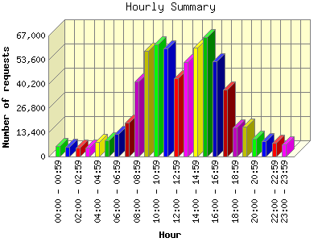
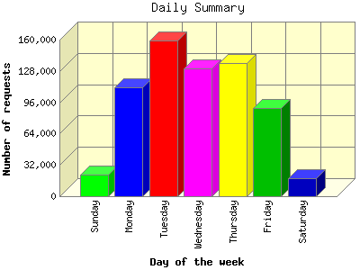
The figures above represent the sum of all page requests from March 11th to December 5th, 2004.
- Searchable database - As of 12/8/04 the CALMAC Searchable Database
  - Contains 684 records representing 576 unique reports.
  - The reports cover programs from 1990 to present and sixty seven percent (67%) of these reports have downloadable electronic files. All of the records without electronic files are either pre-1996 or are appendices to reports that do have electronic files.
  - Forty-three unique reports have been submitted in the past four months.
  - The reports in the database now cover 30 different implementers, of which 21 are third party implementers. Twenty-one (21) unique third party reports are now in the database. Much of the recent success in getting 3rd party implementers to submit reports can be credited to CPUC staff (Peter Lai) efforts to get them to submit reports.
  - During 2003 the visitors requested 95,000 Adobe Acrobat Portable Document File (PDF) documents (~7,600 per month). During the period from March 11 to December 5, 2004 there have been 83,543 PDF files requested, yielding an annualized rate of ~114,000 PDF requests per year (~9,500/month, ~440/work day, ~55/hr, ~1/min.), representing about a 20% increase of 2003. Since the vast majority of PDF documents on the site are in the searchable database, this gives a very good indication of the number of reports requested from the searchable database.

Numbering System –
    - The CALMAC.org numbering system is now fully operational.
    - All historic reports have been given CALMAC.org numbers and on-going programs are being given out on an as requested basis.
    - The CALMAC Website Administrator is continuing to work with Peter Lai of the CPUC and Sylvia Bender of the CEC to try to be sure we capture all third party reports.
    - As requested by CALMAC at the August 17th meeting the Website Committee has instituted a public access page to allow users to search for CALMAC.org program numbers.

Quarterly Report Status
Equipoise has put considerable work into updating the information for the quarterly report. This involved identifying all closed projects, identifying all new projects, setting up new projects, and sending out requests for updating of base information on all projects to each individual project manager. This update process is currently about half complete (about half of PMs have responded). Equipoise anticipates having the first quarterly report about the end of December 2004.

Report Posting
Due to temporary staff unavailability at the CEC, Equipoise took over responsibility for posting and announcing availability of reports starting in early November 2004. This will continue until the CEC can identify and or train staff to resume this responsibility.

Project to date Spent/Spending Status – The website project started in May of 2002 with the purpose of upgrading the website. The following table includes a summary of all spending to date for the website project, exclusive of CEC costs. CEC staff have historically performed the library function for the database, entering and announcing reports and distributing hard copies on request.

Spending to Date on Website/Database
Description | Budget | Spent to Date
Phase 1 – Initial re-arrangement of site and SoW development for Database Rehab. (Complete) | $25,000 | $25,000
Phase 2 – Collection of all evaluation reports for programs post 1/1/94, creation of electronic files, creation of database structure, testing and launching site and database, continued development of site. Hosting of site. (Complete) | $85,000 | $85,000
Phase 3 – Site maintenance and operation. Upgrading of site content, completion of policy manual and site documentation, promotion of site, training of user. Hosting of site. | $50,000 | $47,573
Total | $160,000 | $157,573

As is shown in the summary above, funding on the current work authorization is just about expended. It is anticipated that the remained will be spent during December 2004. PG&E is currently working on activating funds allocated for 2005.

