CALMAC Website Committee Status Report
to
CALMAC Meeting - 08/18/04

The following is A report of the status of the key Website efforts as of August 17, 2004.

Site Statistics – The following are the key statistics on the CALMAC website:
- Searchable database - The CALMAC Searchable Database contains 627 records as of 8/18/04. This is 21 submissions in the past 3 months. In terms of unique reports, this represents 533 reports spanning from 1990 to present. Sixty four percent (64%) of these reports have downloadable electronic files. All of the records without electronic files are either pre-1996 or are appendices to reports that do have electronic files.
- Hits – Website usage can be summarized as follows:
  - Between March ’04 and August ’04 the website has averaged approximately 16,000 page request per month, for an annualized rate of ~192,000 page requests per year. This up approximately 20% from 2003.
  - The most common hours for visits are 8 AM for 5PM during weekdays. This suggests that the primary users are California based businesses. The figures below represent the sum-to-date of all page requests.

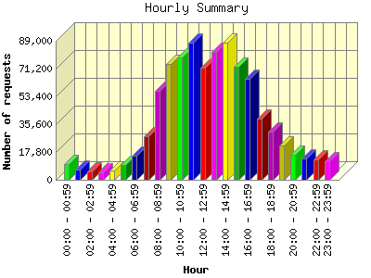
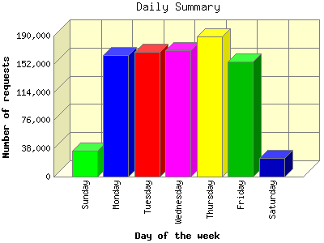
  - During 2003 the visitors requested 95,000 Adobe Acrobat Portable Document File (PDF) documents (~7,600 per month). During the priod from March 11 to August 14, 2004 there have been 52,831 PDF files requested, yielding an annualized rate of ~124,000 PDF requests per year. Since the vast majority of PDF documents on the site are in the searchable database, this gives a very good indication of the number of reports requested from the searchable database.
- Third Party Reports – Third party are now being posted on the CALMAC Searchable Database, sort of. Four studies have been posted so far, but Equipoise Consulting Inc. (the current CALMAC Website Administrator) posted all of them. So it is obvious that efforts are needed to prompt others to post reports to the site. Equipoise has recently sent out an email through the announcement list serve to encourage evaluators or managing entities of third party programs to post the reports on CALMAC.org. Other efforts will probably be required.

Numbering System - The CALMAC.org numbering system was jump-started in July by assigning numbers to all of the statewide projects (See Attachment 1). The Website Administrator is currently in the process of obtaining information on the local projects for 2004-2005 from each IOU to include them in the numbering system. Third party program will be given out on an as requested basis. Finally, the CALMAC Website Administrator will work with the CEC database administrator to retroactively apply the system to historic reports.

Discussion – Quarterly Reports – The CALMAC/MAESTRO Quarterly Reports were requested resumed at the May CALMAC Meeting. The resumption of the quarterly reports was tied to the launching of the CALMAC Numbering System and he awarding of the programs. Now that the numbering system has been initialized, all four IOUs have been contacted to obtain key information on each evaluation project, and to assign numbers to the local projects. Once this information has been gathered Equipoise will compile the information and post it on the MAESTRO Quarterly Reports page on CALMAC.org.

Project to date Spent/Spending Status – The website project started in May of 2002 with the purpose of upgrading the website. The following table includes a summary of all spending to date for the website project, exclusive of CEC costs. CEC staff have retained the library function for the database, entering and announcing reports and distributing hard copies on request.

Spending to Date on Website/Database
Description | Budget | Spent to Date
Phase 1 – Initial re-arrangement of site and SoW development for Database Rehab. (Complete) | $25,000 | $25,000
Phase 2 – Collection of all evaluation reports for programs post 1/1/94, creation of electronic files, creation of database structure, testing and launching site and database, continued development of site. Hosting of site. (Complete) | $85,000 | $85,000
Phase 3 – Site maintenance and operation. Upgrading of site content, completion of policy manual and site documentation, promotion of site, training of user. Hosting of site. | $50,000 | $22,041
Total | $160,000 | $$132,041

Attachment 1
2002 – 2005 CALMAC Project Numbers

