CALMAC Website Committee Status Report
to
CALMAC Meeting – 7/20/05

The following is a report of the status of the key Website efforts as of July 20, 2005.

Site Statistics – The following are the key statistics on the CALMAC website:
- Hits – Website usage can be summarized as follows:
  - Between June ’04 and June ’05 the website has averaged approximately 18,000 page request per month, with a total of 216,468 page requests for the 12 months period. This is up approximately 31% from the same period a year earlier.
  - Overall the number of page requests has risen steadily since August of 2002.

CALMAC.org Page Requests per Month, August 2002 through June 2005
  - The most common hours for visits remain between 8 AM for 5PM PST during weekdays. This continues to suggest that the primary users are California based organizations.
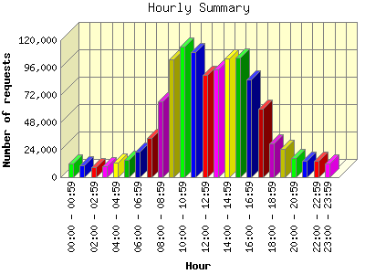

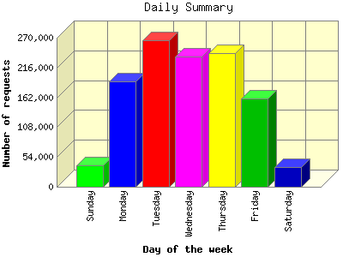
The figures above represent the sum of all page requests from March 11th 2004 to July 16th , 2005.
- Searchable database - As of 7/20/05 the CALMAC Searchable Database
  - Contains 722 records representing 606 unique reports.
  - The reports cover programs from 1990 to present and approximately sixty nine percent (69%) of these reports have downloadable electronic files. The average file size is 1,928 kilobytes and the median files size is 679 kilobytes. This says that there are some very large files, but that the majority (60%) are less than 1,000 kilobytes (1 megabyte).All of the records without electronic files are either pre-1996 or are appendices to reports that do have electronic files.
  - 12 unique reports have been submitted in the past three months.
  - The reports in the database now cover 35 different implementers, of which 25 are third party implementers. Twenty-five (25) unique third party reports are now in the database. Peter Lai of the CPUC staff is continuing his efforts to get third parties to submit reports. An assessment for him completed in July 2005 indicated that 53% of the available the third party programs reports had been submitted to CALMAC.org
  - During 2004 visitors requested 107,505 Adobe Acrobat Portable Document File (PDF) documents (~8,960 per month). During the 6 month period from January 1, 2005 to June 30, 2005 there have been 66,085 PDF files requested, (11,014/month, 499/work day, ~62/ working hour, ~1/ work minute), representing about a 31% increase over the same period in 2004. Since the vast majority of PDF documents on the site are in the searchable database, this gives a very good indication of the number of reports requested from the searchable database.

MAESTRO Project Quarterly Status Report - Status
An updated version of the MAESTRO Project Status Quarterly Report will be posted (CALMAC/MAESTRO/Quarterly Reports) in August 2005, covering the status as of the end of the second quarter of 2005. The report will continue to be updated quarterly in both Microsoft Word and Excel versions. The availability of this report will be announced using the CALMAC list serve. Similar announcements will be made each time an updated report is posted.

Report Posting
Due to temporary staff unavailability at the CEC, Equipoise took over responsibility for posting and announcing availability of reports starting in early November 2004, and has continued to fill this need since then. Recent discussions with CEC staff have made this change permanent. The CEC will continue to be the librarian for paper copies or the reports.

Website Committee Reports to CALMAC
The CALMAC Website Committee has decided, unless CALMAC objects, to decrease the frequency of reports to CALMAC to twice per year. This is being done because the CALMAC website is now fairly well established, thus requiring less frequent reporting, and to decrease the cost of reporting (each report taking approximately 3 hours to prepare).

Project to date Spent/Spending Status – The website project started in May of 2002 with the purpose of upgrading the website. The following table includes a summary of all spending to date for the website project, exclusive of CEC costs. CEC staff have historically performed the library function for the database, entering and announcing reports and distributing hard copies on request.

Spending to July 1, 2005 on Website/Database
Description | Budget | Spent to Date
Phase 1 – Initial re-arrangement of site and SoW development for Database Rehab. (Complete) | $25,000 | $25,000
Phase 2 – Collection of all evaluation reports for programs post 1/1/94, creation of electronic files, creation of database structure, testing and launching site and database, continued development of site. Hosting of site. (Complete) | $85,000 | $85,000
Phase 3 – Site maintenance and operation. Upgrading of site content, completion of policy manual and site documentation, promotion of site, training of user. Hosting of site. | $50,000 | $50,000
Phase 4 – Site maintenance and operation. Upgrading reporting capabilities and support of CPUC and CALMC site needs. | $140,000 | $16,569
Total | $300,000 | $176,569.00

