Minutes of the CALMAC Public Workshop
on the Statewide Evaluation Framework Project

Pacific Energy Center
San Francisco, California
April 28, 2003

Meeting Chairperson: Marian Brown, SCE

Meeting Attendance:
The following individuals attended the meeting in person or via conference call.
(We did the best we could to read the lists or notes and get all the attendees and the names spelled correctly. However, we likely may have missed folks that came on the phone later or whose writing we couldn’t read or didn’t get on the sign-in list. For any such mistakes, we apologize.)

Project team:
Nick Hall - TecMRKT Works – Project Manager | Pete Jacobs - AEC.
Lori Megdal – Megdal & Associates – Team Manager | Ralph Prahl - Ralph Prahl and Assoc. (by phone)
Ed Vine - CIEE (by phone) | Roger Wright - RLW Analytics
John Reed - TecMRKT Works (by phone) | Sharyn Barata – B&B Resources (by phone)
Ken Keating (by phone) | Steve Nadel - ACEEE (by phone)
Marty Kushler - ACEEE (by phone) | Stuart Waterbury – AEC (by phone)
Paul Chernick - Resource Insight

Project Advisory Group
Marian Brown – SCE | Valerie Richardson – PG&E
Rob Rubin – Sempra | Eli Kohlman – CPUC
Jay Luboff – CPUC | Mike Messenger - CEC

Workshop Attendees (in person)
Ann McCormick – Newcomb Anderson / Emcor | Josie Webb – CPUC ED
Ben Bronfman – Energy Trust of Oregon | Kathleen Gaffney – Kema-Xenergy
Betsy Krieg – PG&E | Leora Lawton – Population Research Sys
Cathy Chappell - HMG | Mary Kay Gobris – PG&E
Chris Ann Dickerson – PG&E | Mary Sutter – Equipoise Consulting
Craig Tyler – Tyler & Associates | Michael McCormick - GRA
Sylvia Bender – CEC | Mike Rufo - Quantum
Devra Bachrach – NRDC | Mike Wan – PG&E
Douglas Mahone – HMG | Mona Yew – PG&E
Ed Hamzawi- SMUD | Phil Sisson – Sisson & Associates
Floyd Keneipp – Summit Blue | Rafael Friedmann – PG&E
Fred Coito – Kema-Xenergy | Richard Ridge – Ridge & Associates
G. Escamilla – CPUC ORA | Sami Khawaja - Quantec
Greg Wikler – Global Energy Partners | Steve Schiller - Nexant
Irina Krishpinovich – RNA | Tim Caulfield – Equipoise Consulting
Jennifer Holmes – Itron | Veronika Rabl - Aspen

Workshop Phone Attendees:
Cynthia Mitchell –TURN | Pierre Landry - SCE
Tami Rasmussen – Kema-Xenergy | Mimi Goldberg – Kema-Xenergy
Harley Barnes – Aspen Systems | Bill Steigelman, Aspen Systems
Jennifer Mitchell Jackson – Opinion Dynamics | Karen Hamilton - GHPC
Monica Rudman - CEC | Elizabeth Titus - NEEP
Monica Nevius - CEE | Julia Larkin
Robert Mowris – RW Mowris & Associates | George Kast – LA Water & Power

The minutes reflect comments from presenters and workshop participants on the project. Each slide from the formal presentation made by the project team is shown, along with comments and discussion as applicable. These are the comments recorded and do not necessarily represent thoughts of the project team or the Advisory Group.

The presentation started with an introduction of the project team and presentation of the CALMAC meeting agenda. Next the overall project approach was presented, including a list of project goals, a conceptual overview of the project, the breakdown of the project tasks, and the proposed public meeting schedule. Public comment was taken at the conclusion of the project approach presentation (slide 19).

The following pages present the slides used during the workshop followed by the comments associated with each slide and the related discussion.

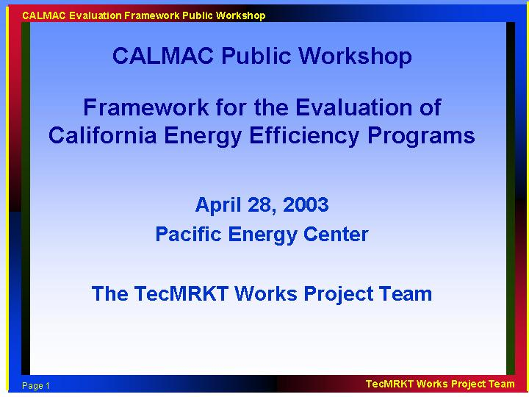

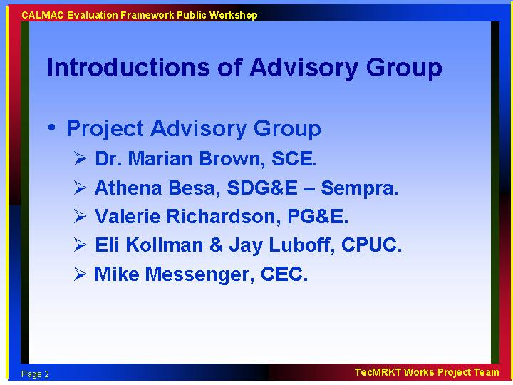

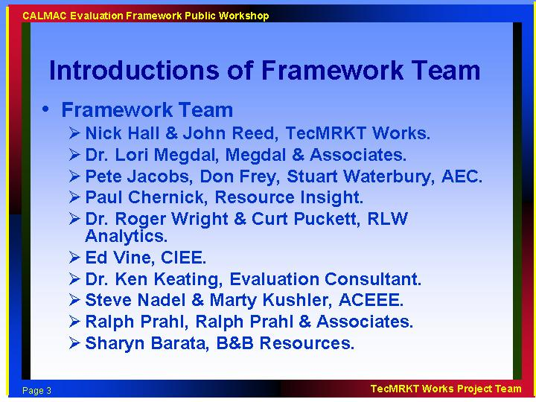

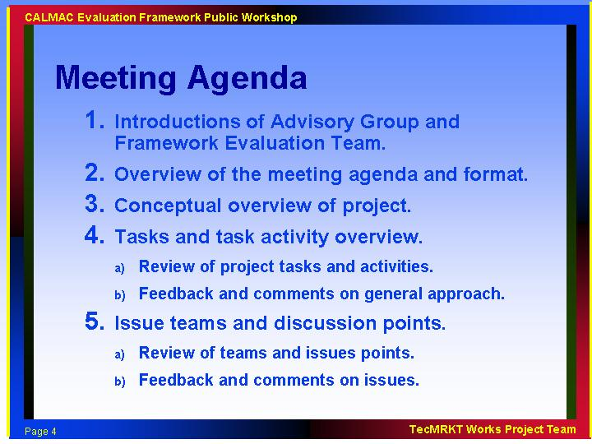

- Most important issue is to take comments and feedback from the public.
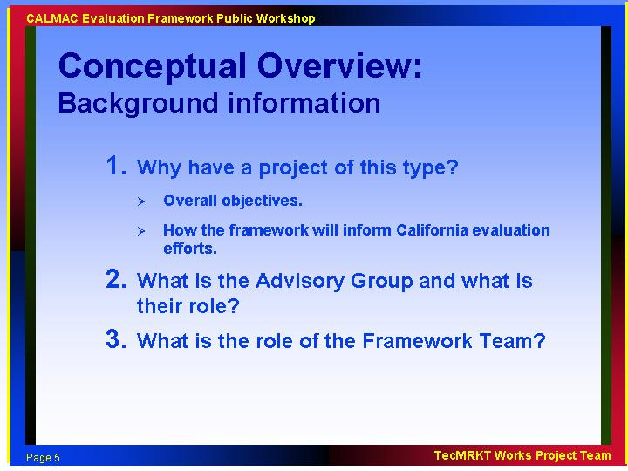

This project is part of the CPUCs strategic policy planning for energy efficiency. The project is viewed by CPUC as an important part of its set of overarching studies and important for efficiency as a procurement resource. There are several overarching studies going on simultaneously that can be viewed as a set. These are:

- Master Evaluation Contract (for current evaluation coordination, reporting and meta-analysis)
- Best practices study
- DEER Study (technical input update)
- EM&V framework study
- Potential study

There will be a need for some level of coordination between these projects. Procurement rulemaking and energy efficiency rulemaking are both involved in decision making on programs, short-term and long-term. It doesn’t matter who is running the program, the reliability issues are the same.

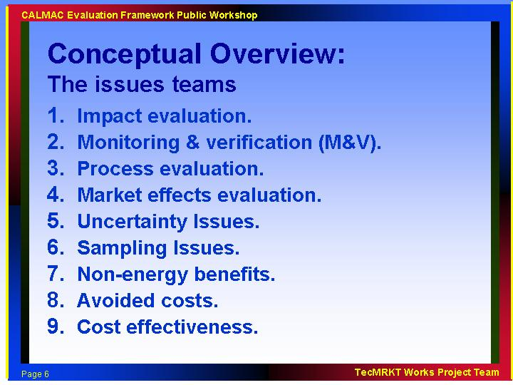

There is significant personnel overlap in the issue teams by design.
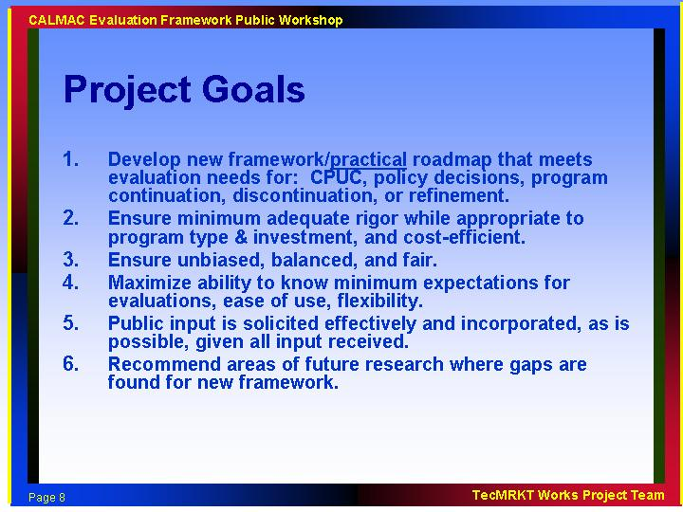

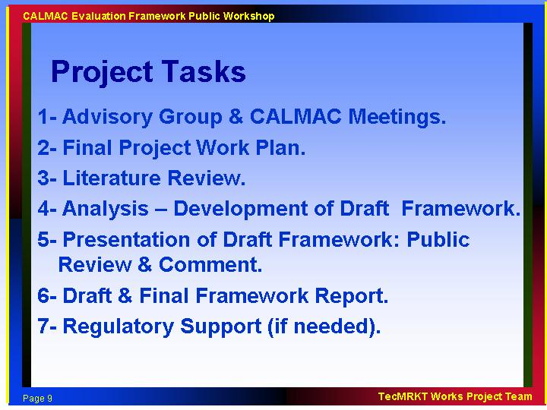

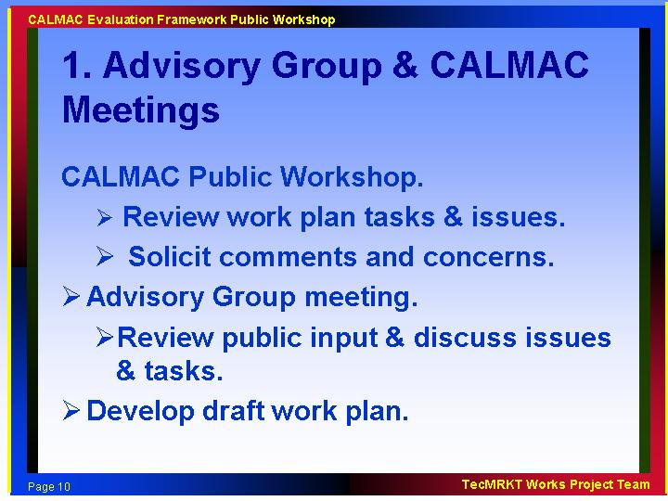

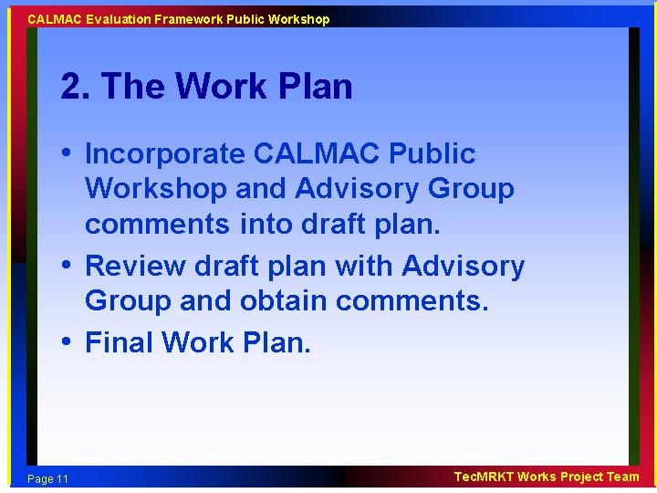

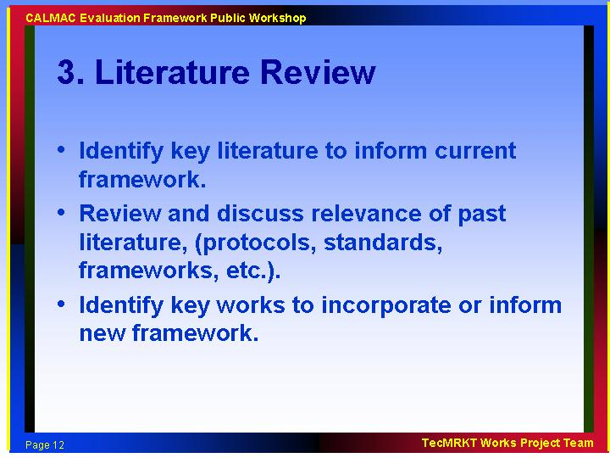

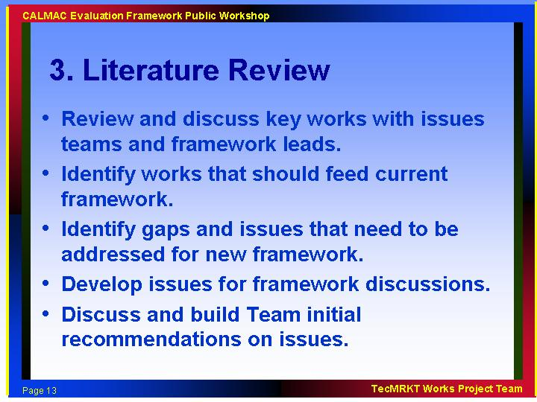

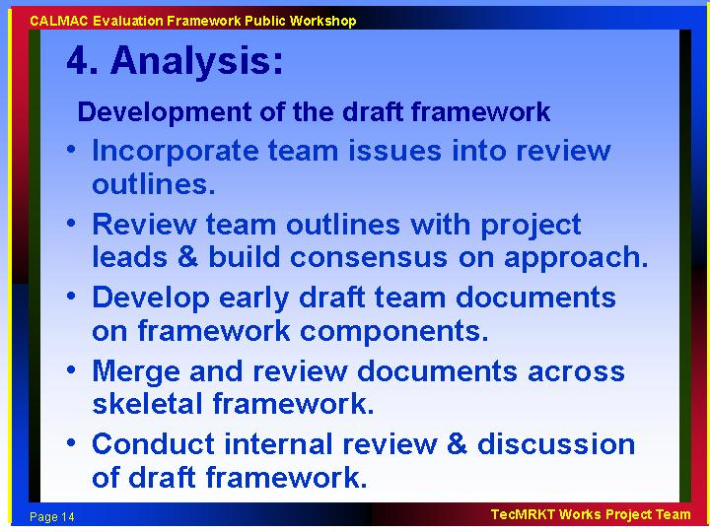

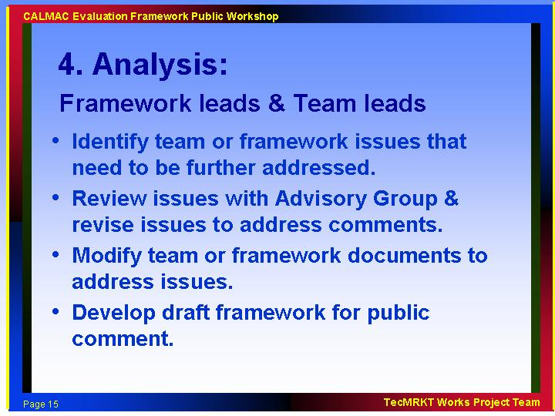

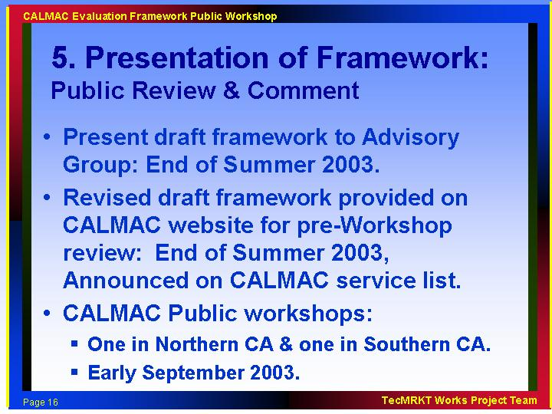

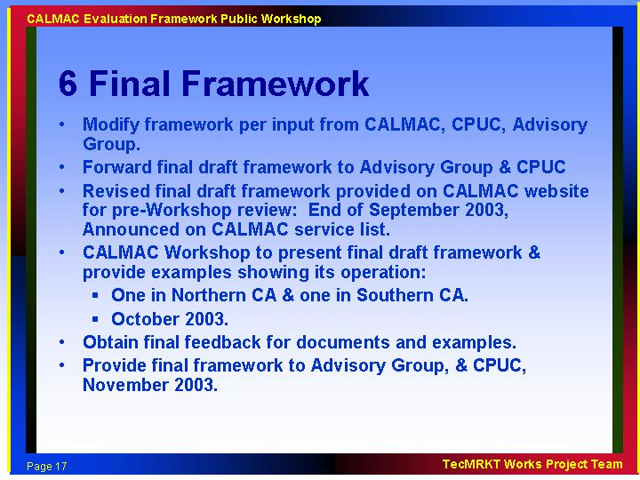

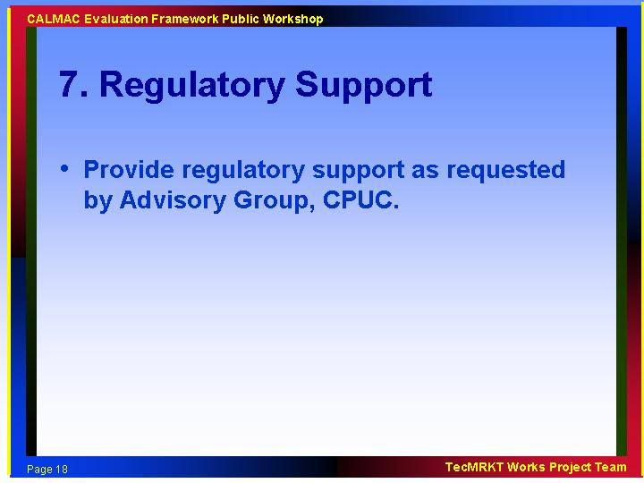

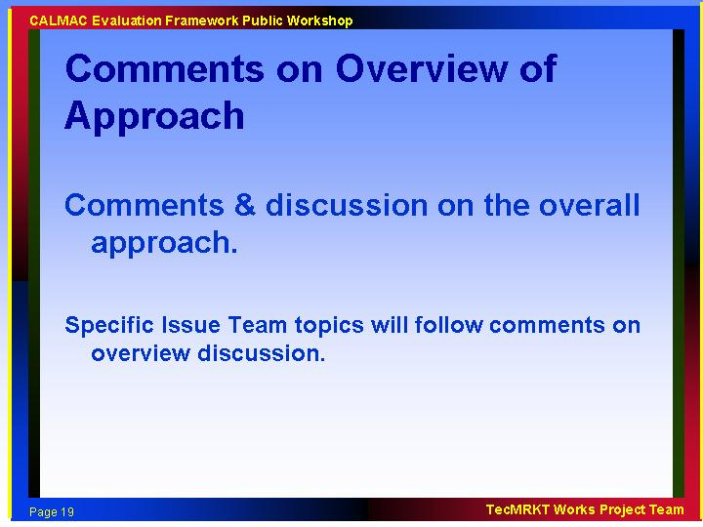

- An intermediate Issue/Decision development piece would help focus the feedback on this process.
- Important end result is to provide expectations for evaluation studies that can guide decision-making

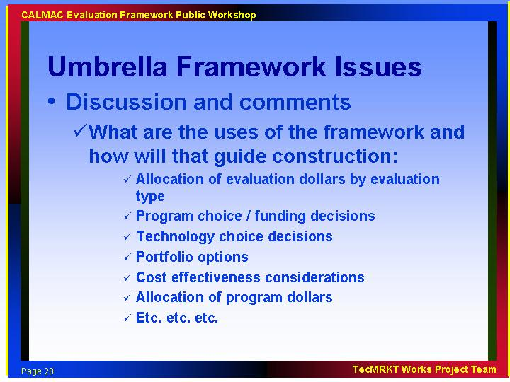

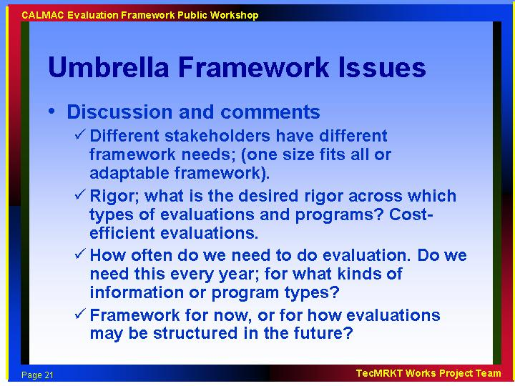

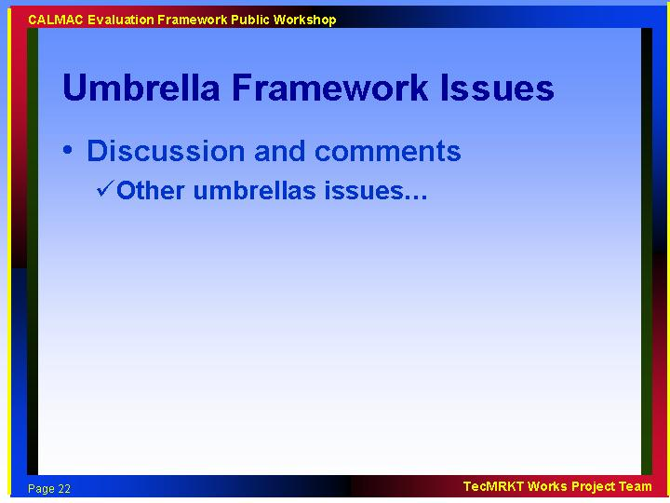

- Should provide a decision tree in the framework so we can see the decision steps for evaluation consideration, but don’t make these decisions a requirement. Allow for waivers.

- If program is providing energy source procurement, what are the minimum requirements for evaluation? Make distinction between measure installation verification and true evaluation and the range of evaluation potential / needs.

- Former protocols made assumptions about the users. We need to know who the audience is. Tension exists between the needs of program administers vs. regulators.

- Examine needs and uses by various stakeholders. Define this and this will define the project boundaries.

- Plan for some requests for earnings from resource procurement in the future; this can influence the need for evaluation.

- There was a comment about the need for non-consultants to inform the framework development process.

- Energy efficiency programs as a resource need to have credibility, which has diminished in the last few years in CA. There is a risk that credibility of energy efficiency’s potential might be lost because of lack of evaluation rigor.

- Old protocols failed to incorporate value of process evaluation. This should be addressed in the new framework.

- Consider how results will be used, timing of evaluation results, use of evaluations not tied to particular programs. Results from old AEAP needed to be in at a certain time, which did not always coincide with the planning horizon for next year’s program. These did not encourage in-process feedback.

- Three other studies are currently being conducted which overlap with this study. Consider how these other studies provide input to this project. Since PG&E is monitoring 2 of the 3 new studies, project manager should make sure the information gets transferred (Best Practices study and Potential studies).

- Plan in the need to have resources to push the evaluation envelope so that we are improving our evaluations. Let’s not do it the same way each time. Look at methods, study techniques, and lessons learned from evaluation research in other fields, such as health care.

- Need to narrow the study to focus on offering specific advice on how to conduct the evaluation; e.g. the mechanics.

- Define the role of the administrator/implementer vs. the evaluators. Might be living dangerously. Continuing evaluation blurs distinction between evaluator and the administrator/implementers.

- Need a third party review process when an evaluation is complete. Might help with implementer/evaluator relationship.

- List what is in the scope of the framework project. Outline what is provided for each of the user groups: Administrators/ implementers/ regulators/ customers. Solicit user needs by email.

- Need to evaluate the entire system - step back and look at the system from a portfolio perspective. Study the interaction of the various parties (CEC, CPUC, utilities, ORA, etc) once every 10 years. How has the whole structure worked? Where will meta-evaluation issues, overall monitoring and assessment issues be addressed? Ask each party what they need from the framework. That is, have regulators, program admins, and others tell you what they want from it. This was not done for the last framework, and it suffered from it. You need the opinions of the users.

- Provide guidance on funding decisions. Look at providing metrics on funding based on TRC. Consider adding some rules of thumb, like “if your program’s TRC is >x, increase the funding.” Emphasis on the life cycle of the program. Infant programs may have bad TRC that improves with time, mature program TRC may taper off as market becomes saturated.

- The Framework needs to look at hierarchy of uses. Use drives the product. Still some loose issues on incentives. Need evaluation framework to evaluate and authorize a portfolio and not just a single program.

- Don’t drive decision tree down to technology or end-uses. Will get too complicated.

- Address who the evaluators are – who hires them, and what pot of money is used to pay for them.

- Address conflicts of interests.

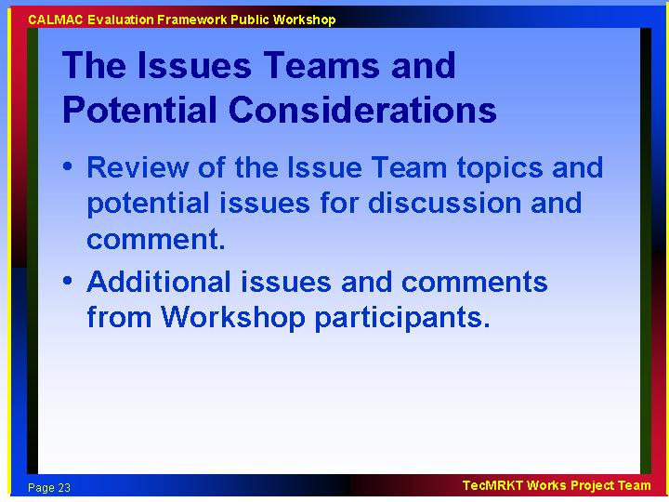

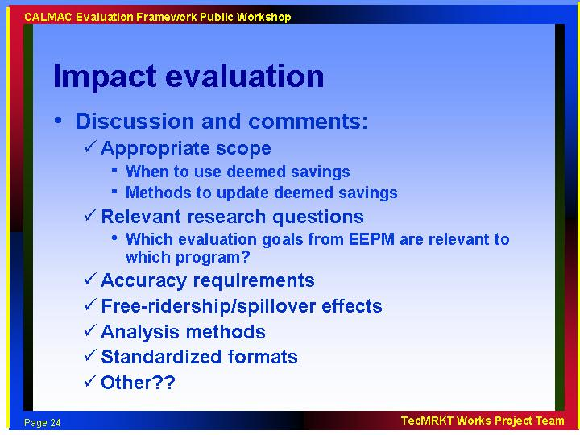

- How do you deal with some of the over-arching issues such as some of the marketing efforts? Is that part of the impact component so that a credit is given to the marketing side of the issue? Is the impact a result of the marketing efforts or the measure installation effort?

- Impact means kW, kWh, therms. How are we going to deal with the uncertainty issues? Elements of bias and precision exist in all evaluation studies. We need a good discussion on these issues so that people know how certain we are on the findings. Resist political pressure to focus on single point estimates; develop explicit approaches to quantify uncertainty.

- What are the needs of system planners? Identify their needs and include these issues in the framework. They have specific needs for rigor and quantification of uncertainty. What do system planners need for demand evaluation? Which metrics will be required (system coincident peak, demand savings over a specified time period, etc.) These need to be defined and addressed. Note: system planner needs will be addressed in the Market Potential Study

- Include distribution engineers in the user needs identification process.

- Are we talking only about ”hard” savings? Consider a system of evaluating impacts for information-only and outreach efforts?

- When is it appropriate for information efforts to claim savings? What is the purpose of estimating savings from information programs? Are these to show influence or to include savings for system planning (therefore, needing impact-level evaluations)?

- We need to identify why we want information programs and look at how marketing feeds the impact results.

- Need a statewide marketing effort, but may not need kWh savings estimates from the marketing efforts. Consider looking at marketing campaigns differently, not trying to evaluate impacts separately. Might be more useful to look at marketing effectiveness than impacts.

- Do not forget the past; use the past framework efforts when ever possible. There is a lot of good prior work to be used in this framework, particularly in the area of impact evaluation.

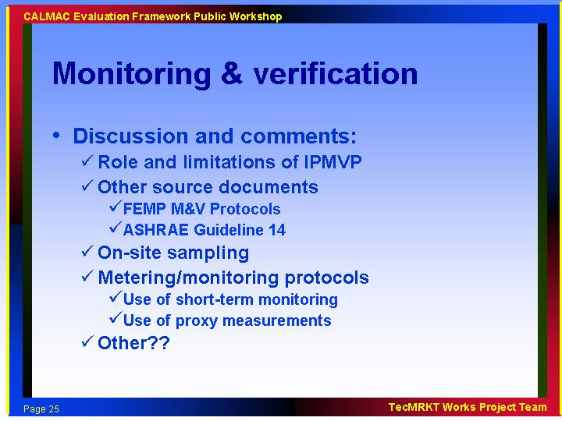

- What are we monitoring and verifying? What is covered in this topic? Are we simply to verify if the measures are there and properly installed? May need a new name if issues are wider.

- This involves building science research and can be thought of as extending the field of building science research, rather than focusing on a particular program or technology. Describe how M&V should be used to examine how a technology is used in the market. Develop a database of building science information that is technology and building specific. Develop reliable results so expensive M&V does not need to be done over and over. Unknowledgeable users can waste a lot of money doing fieldwork.

- Look at past persistence and technical degradation studies to identify holes that require long term M&V and areas where additional long-term studies aren’t necessary.

- May want 1st year M&V, then persistence & degradation. May look at minimum appropriate M&V if deemed doesn’t fit.

- For new technologies and technologies where we need more data, what do we want to consider in the impact evaluation? Need to have the framework show steps and decisions on how and when to use M&V for impact studies.

- The assumption is that you need to go to the field. But some things need to be studied in the laboratory rather than the field. Other technologies are better studied in the field. This section of the Framework needs to deal with this issue.

- Consider the role simulation modeling in M&V, especially in new construction programs.

- Is this a monitoring protocol? Many fine documents on monitoring protocols that can be referenced.

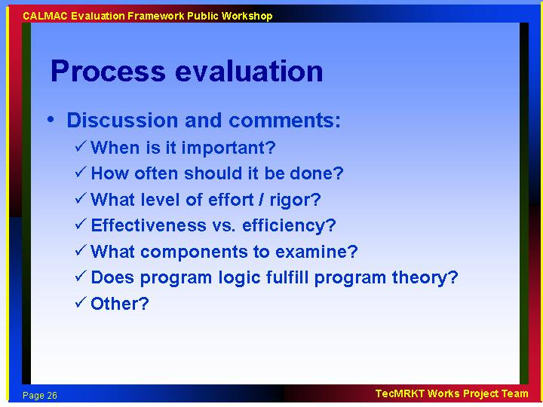
- Cover the components of a process evaluation – internal (staff), interactions with customers, other? What metrics to report (effectiveness, efficiency, or both)? Lay out the issues that various types of programs need to address.

- Ask when and why doing a process evaluation - when in terms of the project timeline. Do it earlier rather than later to get feedback to implementer during the current program year. Value of process evaluation is on-going.

- Note that best practices people are looking at the same kind of issues, and this needs to be addressed. Consider interaction with all the studies going on over next few months

- Process evaluation is not valuable unless you know who is using the information. What happened, why, how can we improve? Don’t separate these questions. Provide different process evaluations for different stakeholders. Implementers are interested in very specific questions about a component of a program, where regulators are looking at bigger picture, such as after the fact prudency of expenditures, effectiveness.

- Need for statewide studies to break down process issues. Evaluation is one of the program best practices that will be studied.

- Field measurements inform the process evaluation. Maintenance is a process issue. M&V can inform in-stream process evaluation.

- Program theory and logic models for each program are increasingly considered a best practice nationwide.

- How do you avoid the gotcha factor – how do you answer the dirty wash question? How do you frame the response and present the results?

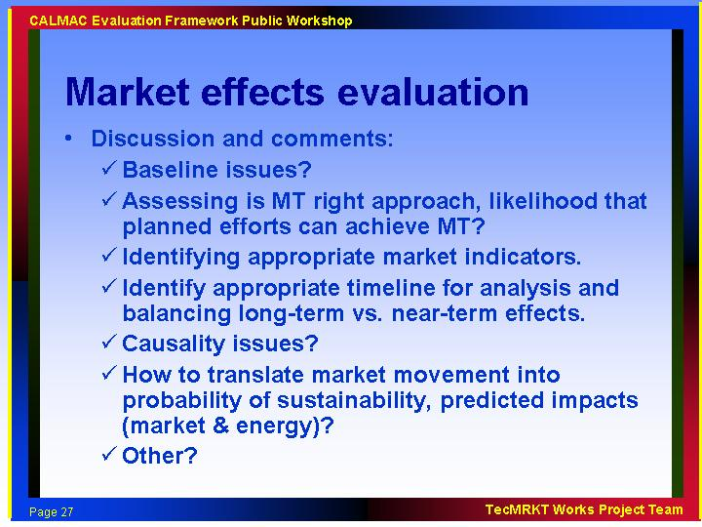

- What does “market effects” mean – saturation, operational changes, technology mix changes, market transformation issues, short term vs. long term, etc?

- Is there a place where saturations fit in? Saturation is more an issue for portfolio rather than individual programs, where MT is typically related to specific programs. Can you track markets relative to portfolio? Consider this as the framework for ME studies. How does it fit into overall policy framework? What is the appropriate timelines?

- This should include the nonres/res market tracking studies already being done. We also have saturation studies that inform the energy code process.

- We should get away from program-level market effects evaluation to portfolio issues (with measurement every 2-4 years).

- Users for this information need the portfolio information or whole system information not just program-specific information, but the whole system. Define what level of program evaluation data is needed for portfolio management and what for program-specific evaluation.

- Parameter that is not often studied is adoption rate. Lots of numerators, but not many denominators. Look at participation rate and potential participation rate as factors within impact evaluations to make these studies more useful for demand forecasting and potential work.

- Look at prioritization of market actors within programs, e.g. home inspectors as an audit resource.

- Look at effective alternative intervention points, e.g. upstream vs. downstream players.

- Market effects studies need to look at naturally occurring conservation vs. program effects. From program planning perspective, when does a technology get to a takeoff point. Try to establish causality and attribution.

- From a portfolio point of view, the process is related to how well portfolios impact markets. Best portfolio will have the best processes. Can you track overall markets in relationship to portfolio activity that will allow you to decompose various types of programs, and add it all up to a market impact? Should consider the framework under which this kind of evaluation takes place. Address how this fits into an overall policy framework, and the timeline under which you should conduct or update market effects studies.

- Focus should be on when you hit sustainability in the marketplace, or need to change program. Focus on who is managing portfolio and what they need. When do you know when the market is changed to the point where the program can begin winding down?

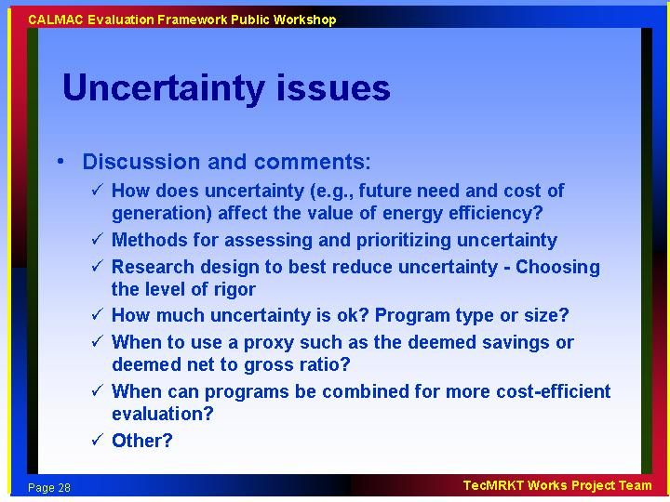

- Uncertainty is present in everything, need to have a clear picture of how certain we are of all evaluation findings.

- Thrilled that this topic is on the list. Need to include risk as an explicit perspective. Other relevant work has already been done in other areas such as product management.

- Need to include basic education about this topic for policy makers on what’s involved here. Regulators don’t fully understand uncertainty. Need to explain bias vs. uncertainty/precision. Education on the issue is more important than specific advice.

- Explore the variability in measurement vs. the variability in energy savings. How does uncertainty in a parameter project into the final result? Devote resources toward most uncertain variables that can be addressed. When are the results different than zero?

- Address tradeoffs between budget and uncertainty reduction.

- Need to consider the context. Uncertainty when incentives are involved may have a different dimension. Program modifications and design that are tied to yearly rate cases, is an issue, because they can’t be changed for some period of time once they’re set. Some consideration needs to be made to alternative regulatory environments waiting for us out there in the future. The framework needs to inform the future as well as the present.

- Discuss how to deal with and plan under uncertainty, because there’s a point at which throwing more money at it doesn’t help. When do we stop evaluating because we can learn no more than we already know?

- Develop a framework for measurement and evaluation data storage. It is difficult to find data from other studies that can be used to inform current programs or studies. Catalog and enter data into a database, along with the measurement uncertainty. Similar efforts exist in the medical field.

- Accuracy vs. shareholder incentives. Need to keep accuracy criteria constant regardless of incentives. (3rd party profitability may be equivalent to utility incentives for efficiency services.)

- Bound uncertainty of tools (DOE-2, Calpas) and then add in sampling, persistence, load factor of program.

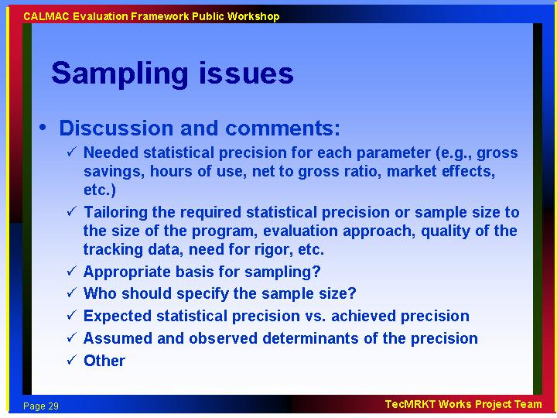

- Sampling addresses uncertainty, make sure the linkages are in the framework.

- Survey sampling versus power impact. Sampling protocols by program type.

- Distinguish between sampling uncertainty and uncertainty in other information. There is the uncertainty associated with sampling, uncertainty associated with the results, uncertainty associated with the use of the information at the program level, the portfolio level, the policy level.

- Provide basic information about level of variability and uncertainty associated with some key common parameters, e.g. operating hours, to help guide sampling decisions, changes in processes, etc.

- Underlying distribution information would be very helpful to evaluators.

- Address sampling unit uncertainties (measures? Households? Rebate applications?).

- Explain the relationship between uncertainty, sample size, methods and costs. At what point do we get diminishing returns?

- Who should specify sample size? There may be a conflict of interest in asking bidders on evaluation work to specify the sample size.

- Assume a sampling protocol for all, or some types of programs, but don’t be as prescriptive as the CADMAC protocols, put in some flexibility depending on the use.

- Need to have comparability across programs.

- Importance of standard measurements. Be clear about how the measurement was taken. How a measurement is taken can be more important than the measurement.

- Provide an education piece about sampling for when probability is not uniform across every unit in the population.

- Education on statistical precision versus achieved precision.

- Consider cost efficiency when developing sample sizes.

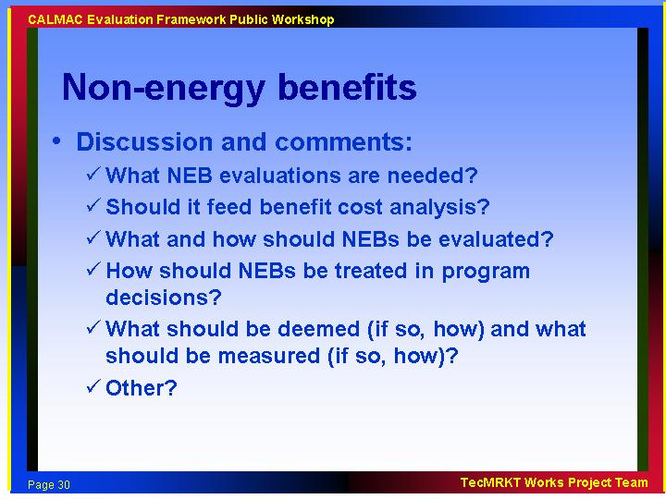

- Low-income programs already include non-energy benefits, but this framework is not addressing low-income programs. That is a different group, and they will deal with the low-income program evaluation efforts and needs.

- Water savings are an important non-energy benefit: 2.2 to 2.0 gpm showerheads, washers, industrial processes improvements such as food processing where reduced waste, water consumption and other non-energy benefits are important. For example: food can get out of the field and into the can quicker with less waste and costs. These are real savings and programs are not getting credit for them in the standard energy efficiency evaluation framework.

- This is an enormous topic, would rather frame it in more general terms that people can use. Think how hard it is just to quantify savings to risk managers in energy markets! List documentation requirements as a minimum. Provide guidelines for quantifying the NEBs.

- At what level should NEBs be applied? Suggest program or market level, not measure level.

- Include emissions reductions as a NEB.

- NEB evaluation depends on the needs of the audience. Not important unless a major part of participation decision. Have procurement people take this on.

- Important to get CPUC to identify up front if there are specific NEBs that they want measured. There’s kind of an NEB policy in CA—they want to measure NEBs to hard-to-reach pops, for example. Should identify up front by policy-making body rather than doing it randomly. Identify as a policy goal – not up to consultants to decide.

- Move this topic to the CPUC overarching study.

- NEBs in the framework should focus on their impact and influence as it relates to obtaining energy savings or impact reductions, not NEBs research just to understand the total impacts of a program beyond energy. Should be tied to obtaining energy impacts. Not prescriptive NEBs but need this information if it is why participation occurs.

- Role of NEBs in approving/screening programs versus improving programs.

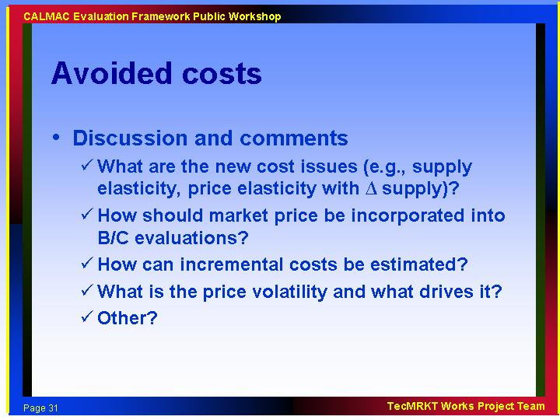

- Perspective on this has changed quite recently, since now PUC is going to be putting out an RFP for avoided costs work in parallel with this project. The question is how this work would overlap/complement/guide other project.

- Consider avoided costs of T&D.

- Look at consistency with respect to general rate case.

- Costs of electricity, benefits of other than electricity need to be consistent. Be clear about timeframes and what avoided costs you are considering.

- This issue may at least provide input to the rest of the Framework on what needs to be measured in energy efficiency programs to provide the data that avoided-cost calculations could use, and to the avoided-cost group on the information needed by program designers; e.g. shapes and consistency of load reductions related to weather, or timing and location of load reductions that would produce T&D issues.

- Will be taken up in larger CPUC study. This study may want to inform the larger study as well as deal with it to some degree in the framework. The framework should have an avoided cost section and discuss the issues of its use and function and influence on evaluation.

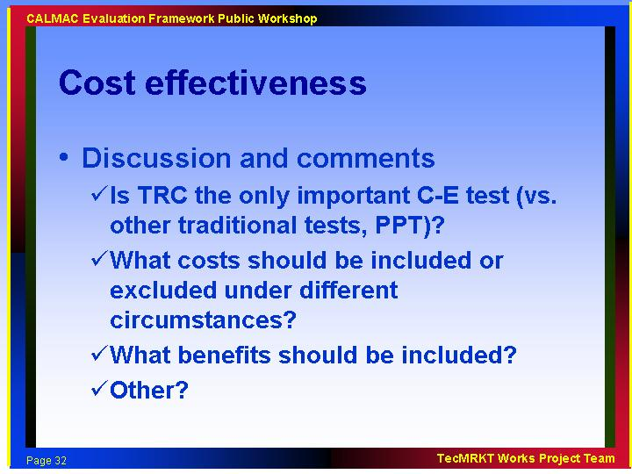

- Use this study to lay out data needs relative to evaluation. What data needs to be gathered and how often? Give guidance on components that need to be updated such as measure costs in cost effectiveness calculation data streams.

- Standard Practice Manual is not clear on this issue. We have many revisions, not clear what is most important.

- Public Purpose Test not codified into the Standard Practice Manual. TRC used in practice. This should be raised in Framework study. What tests should be used for what reasons, what decisions, etc.

- Cost-effectiveness for programs, measures, projects, and improvements.

- Can TRC for screening be reconciled with design of programs for best outcome for consumers and the public?

- Are cost effectiveness calcs a threshold measurement for program decisions or comparative between programs for portfolio or other decisions?

- Consider the uncertainty of cost effectiveness calculations, especially for programs with benefit/cost ratios of 0.98 or 1.01. Need to bound these ratios so that we know what they really mean (1.25 is different than being 80% sure that it is 1.25+/- .75).

- Would be useful to relate cost effectiveness back to impacts, how data needs to be gathered, when to gather, etc. Suggest requiring evaluators to give feedback on what components of cost-effectiveness need to be evaluated, on annual basis, and on other basis.

- Consider how often to do benefit cost estimates. Do we need these every year for the first 5 years then only every 3-5 years or after a significant change?

- Need to be consistent in terms of costs and benefits, e.g. if you include non energy benefits, need to include a broader measure of non-energy costs, or stay narrow on both sides, since these are funded by energy bills.

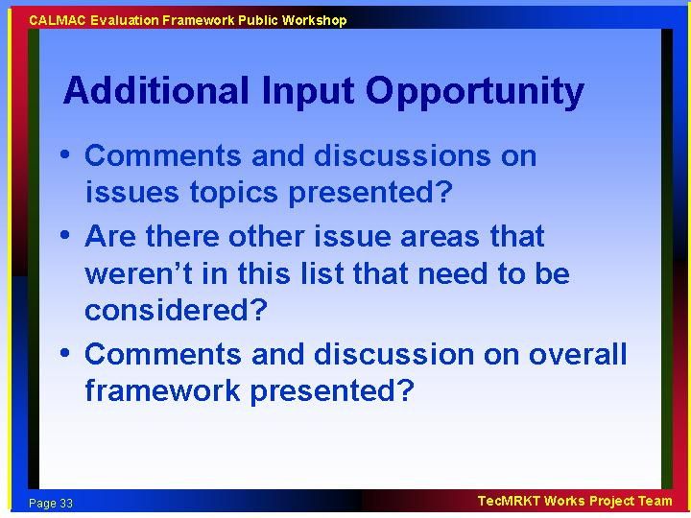

- Work backwards from the questions you need to answer so that the framework deals with the issues that address the key questions.

- Are you going to consider reporting requirements?

- We don’t want to start with reporting requirements, because they should be developed out of a broader sense of what people need to know and what they don’t. Would rather have discussion about what critical pieces of info are needed at policy and program level, and from there go to reporting requirements on policy and evaluation guidelines.

- Recommend a regulatory structure for evaluation; e.g. must evaluation plans be developed in advance and approved by whom?

- Have framework come up with a set of minimum requirements for each of the 9 evaluation areas. Link these to market barriers & market actors. Use this approach to bridge gap between the practical and the big picture/policy.

- Reporting requirements should be developed for gaining an understanding of what information is needed for various stakeholders. Include early feedback loops, process evaluations. Allows meta-analysis to proceed based on comparable information. Summary study of 2001 programs. IOUs, state efforts, munis, 3rd parties. Lots of gaps in data. Moving forward an important issue to address in evaluation context.

- Don’t forget the need for evaluation beyond the program level and the need to look at the evaluation process and how well the process is working. Don’t forget that we also need to evaluate the whole California PGC process and if it is doing what it needs to do.

- Need policy objectives to guide the reporting requirements.

- Need a straw man for protocol so people can see how it is used, otherwise it is not as useful. Walk programs through the roadmap. Show examples of different paths for different programs.

- Address the review of plans. What is the level of review needed, by whom?

- Make a list of priorities for each topic area. Develop a list of minimum questions for all process evaluations. Develop standard formats for M&V formats. Provide a first, second, third tier approach based on budget.

- Make recommendations for a process evaluation of the entire EM&V process.

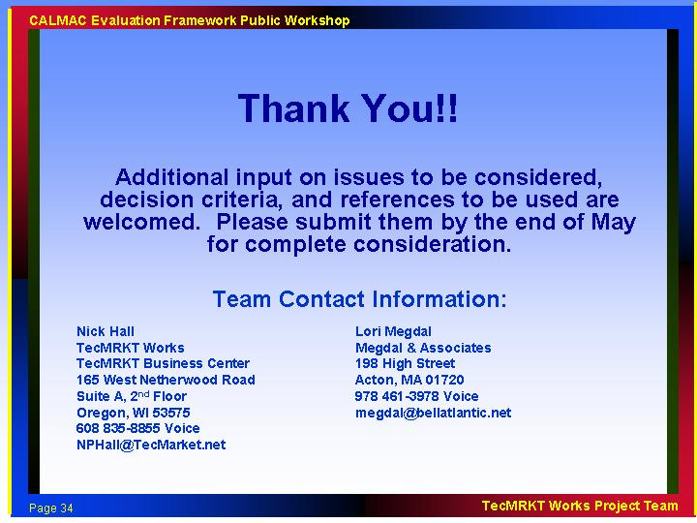

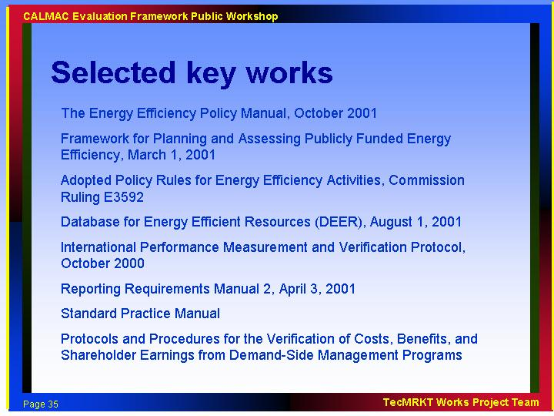

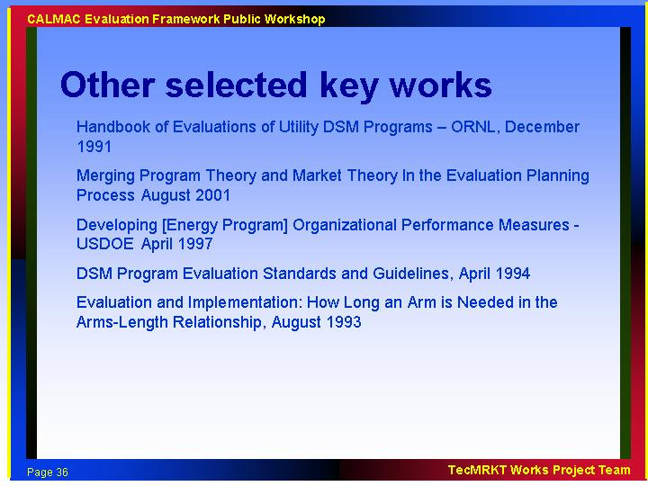

The following figure was not presented at the workshop, but is included to provide a perspective on the concept of the roadmap approach. This figure applies strictly to impact evaluation, but is representative of other flow charts that can be developed under the framework effort.
