Adopted Minutes for Website Committee Conference Call
11:00 AM, Thursday, October 12, 2004

Attendees:
Craig Tyler – PG&E
Pierre Landry – SCE
Peter Puglia– CEC
Bill Junker – CEC
Tim Caulfield – Equipoise
Peter Lai – CPUC
Mary Wold – SDG&E
Sylvia Bender – CEC

Executive Summary
The CALMAC Website Committee held its regular monthly conference call to address the items shown in the attached agenda. Mostly the call covered (1) the addition of the numbering system to the site, (2) updating specific website functions, and (3) website statistics.

Minutes of Conference Call (in order of agenda)
- Approve minutes of September 16, 2004 Website Committee conference call. Minutes Approved
- Incorporation of Third Party reports into database. Creating a list of third party studies to be sure we get them all (Pete Lai/Equipoise). Have list from Peter Lai. Comparing to database. Sent to IOUs and CEC. Will be updated as feedback arrives.
- Low-income report incorporation. Six submitted, six additional promised, searching for additional reports.
- Adding 1-4 pagers to Search Results – Plan to add this functionality only for main report, not on volumes or appendices.
- Add report submission guidelines to website. A button will be added on the Administration page next to submit a report so that users can pull up this documents if they want to. Also Concieo will add an “Introduction to Website” button on home page that will pull up the Power Point training document, showing them how the website works.
- Allow the saving of a draft version of the report submission form, if people get interrupted or need to break off for any reason. Conceio has offered two solutions: Password protected or reference number. Plan to also have a time out on draft documents so garbage doesn’t accumulate. Discussion during the call questioned the necessity of this option. The committee decided to shelve the idea unless we have further requests.
- Implementing the CALMAC.org numbering system.
- System now complete, live on web.
- We need to work to get the numbers used within our companies/organizations.
- Numbers not downloading in printable version of the report. Request put in to Concieo to fix. [Post Call Note: Review of this issue identified that when the search results were printed from Internet Explorer the right side of the page was cut off, not just the numbers. Equipoise put in a request to Concieo to fix the problem.]
- Quarterly Reports – Should have started at the beginning of the month. Will start in the next week.
- Routine site statistics reporting process. See attached quarterly site statistics report for the website. Do we need a quarterly Website Committee report? Do the minutes of the meetings and reports to CALMAC serve this purpose? Committee decided that committee minutes and CALMAC reports are adequate.
- Any other important issues about the site?
From the minutes of the previous CALMAC Website Committee Conference Call, dated June 16, 2004. Attachment 1, first table. All 2002-2003 evaluations should have separate project numbers. Equipoise will assign and a corrected list to the committee members and the IOUs.
Next meeting at the regular time and date, November 9th at 11:00. Same call in number. An agenda will be sent in advance of the call.
Meeting adjourned 11:30 AM.
Draft Agenda for Website Committee Conference Call
11:00 AM, Tuesday, October 12, 2004

- Approve minutes of September 16, 2004 Website Committee conference call.
- Incorporation of Third Party reports into database. (1) Creating a list of third party studies to be sure we get them all (Pete Lai/Equipoise).
- Low-income report incorporation. Six submitted, searching for additional reports.
- Adding 1-4 pagers to Search Results – Progress report.
- Add report submission guidelines to website. Button on Administration Page next to submit a report. In the works.
- Allow the saving of a draft version of the report submission form, if people get interrupted or need to break off for any reason. Working with Conceio.
- Implementing the CALMAC.org numbering system.
- System now complete, live on web.
- We need to work to get the numbers used within our companies/organizations.
- Quarterly Reports – starting process.
- Routine site statistics reporting process. See attached quarterly site statistics report for the website.
- Any other important issues about the site?
CALMAC Website Quarterly Statisitics Report
10/07/04

Site Statistics – The following are the key statistics on the CALMAC website:
- Searchable database - The CALMAC Searchable Database contains 650 records as of 10/07/04. This represents 22 submissions in the past 50 days (since August 18). In terms of unique reports, this represents 555 reports spanning from 1990 to present. Sixty four percent (65%) of these reports have downloadable electronic files. All of the records without electronic files are either pre-1996 or are appendices to reports that do have electronic files.
- Hits – Website usage can be summarized as follows:
  - Between March ’04 and October ’04 the website has averaged approximately 16,500 page request per month, for an annualized rate of ~198,000 page requests per year. This up approximately 20% from 2003.
  - The most common hours for visits remain between 8 AM for 5PM during weekdays. This suggests that the primary users are California based businesses. The figures below represent the sum-to-date of all page requests.

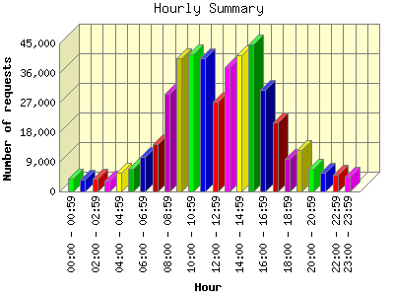
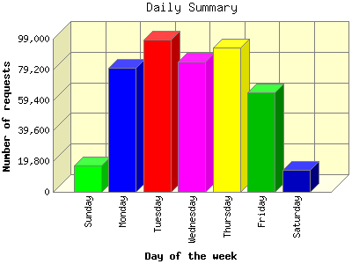

  - During 2003 the visitors requested 95,000 Adobe Acrobat Portable Document File (PDF) documents (~7,600 per month). During the priod from March 11 to October 2, 2004 there have been 68,237 PDF files requested, yielding an annualized rate of ~121,000 PDF requests per year. Since the vast majority of PDF documents on the site are in the searchable database, this gives a very good indication of the number of reports requested from the searchable database.
- Third Party Reports – Third party are now being posted on the CALMAC Searchable Database, sort of. Ten third party studies have been posted so far. Efforts are continuing to assure that reports for all evaluations of third party programs are posted on CALMAC.org.
- Low Income – There are currently 18 low-income sector reports on the database. Approximately 10 additional historic studies have been identified and are being pursued.

