CALMAC Site Statistics
April 1, 2015 through September 30, 2016
Background: This report summarizes CALMAC.org website statistics for the period from April 1, 2015 through September 30, 2016. The statistics in this report are collected using Google Analytics, a web based statistics collection package. This package removes visits created by spiders and bots from the statistics. As a result of this change there is little ability to compare the following website statistics to those reported for periods prior to March 2014.
Findings: The overall results for the 18 month period covered by this report show a pattern of use of the site that varies depending on the posting of new reports to the site. The majority of the new evaluation reports are posted in April through July, resulting in a peaking of report retrieval activity on the site during those months (Figure 1). Over the 18 month period 19,800 sessions and 65,095 page views were recorded. Since a session represents a visit to the website, this means that on average approximately 254 people went to CALMAC.org each week to find information. This is a 19% increase over the previous reporting period of March 2014 through April 2015.
Figure 1

Figure 2 shows that 65 percent of all visits to CALMAC.org were from the United States. This is a change from the previous report when 79% of all visits were from the US. An interesting development is the high level of visits by sites located in Russia. Whether these visits are serious enquiries or some type of spam from Russian servers is unknown. Similarly the percentage of “(not set)” (i.e., country of origin not identified) went from not less than 1% to approximately 5% since the prior report. Whether this is real use of the site or an artifact of other activity will be investigated. The UK, Canada and Brazil have remained at the 2% to 3% level. The main point is that the majority of the interest in the site remains US in origin. Of the 12,876 sessions originating in the US, 6,419, or roughly 32% of all enquiries, originated in California.
Figure 2

Figure 3 shows that approximately 67% of all page visits are to the CALMAC Home Page, Search Page and the Results Page. This is unchanged from the previous reporting period, and continues to confirm the preconception that CALMAC’s main present day function is for storage and delivery of reports via the web.
Figure 3

Figure 4 presents a flow diagram illustrating how users enter the site and how they subsequently interact with other CALMAC webpages (this diagram is based on a sample of 20,000 events). The vast majority (77%) of users enter CALMAC.org through the CALMAC Home Page or the Search page. Subsequent interactions lead to searches for reports, report search summaries, and finally approximately 13% of all sessions lead to the download of reports.
Figure 4
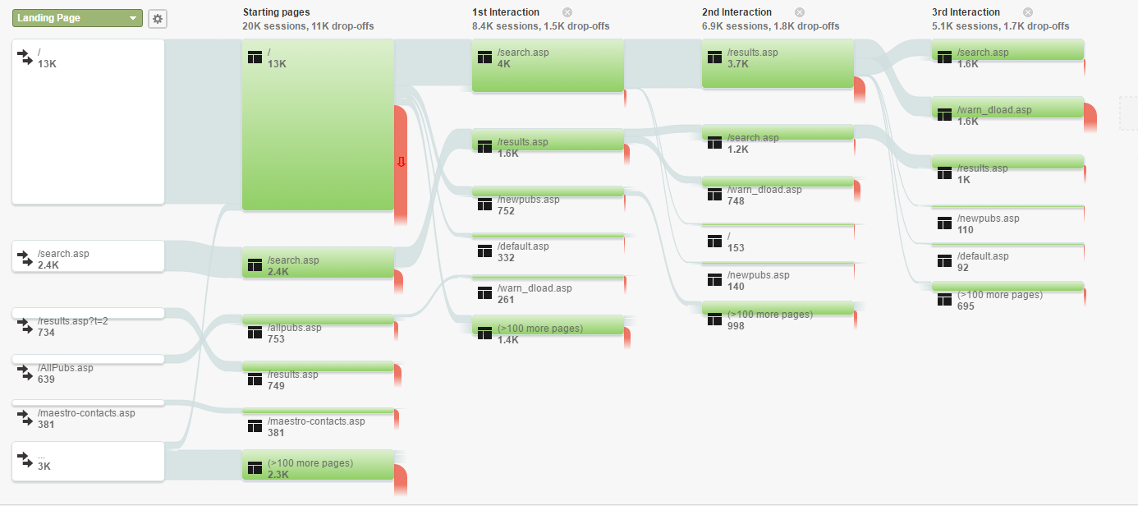
Operationally the website is extremely stable, experiencing virtually no shut downs, and the few that have occurred have been very short in duration. The site speed is very good and is totally acceptable for purpose of the site.
Conclusions: CALMAC.org is fulfilling its primary function of making results available for download, facilitating searches for relevant reports, and is resulting in download of approximately 2,500 report files per year.

